Circular Motion 1

1. When a particle moves in a circle with constant speed, its acceleration is
A) constantly increasing. D) constant in magnitude.
B) constant in direction. E) constant in magnitude and direction.
C) zero.
Explain your answer:

2. An object traveling in a circle at constant speed
A) is moving with constant velocity.
B) may be slowing down or picking up speed.
C) experiences no acceleration.
D) experiences an acceleration toward the center of the circle.
E) is described by none of the above statements.
Explain your answer:

3. A car going around a curve of radius R at a speed V experiences a centripetal acceleration ac. What is its acceleration if it goes around a curve of radius 3R at a speed of 2V?
A) (2/3)ac B) (4/3)ac C) (2/9)ac D) (9/2)ac E) (3/2)ac
Explain your answer:

4. A particle is moving uniformly in a circle with radius 50 cm. The linear speed of the particle is 60 cm/s. The acceleration of the particle has a magnitude of
A) zero B) 36 m/s2 C) 1.8  105 cm/s2 D) 72 cm/s2 E) 3.6 m/s2
Explain your answer:

5. 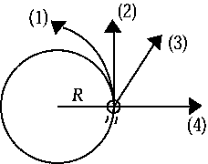
The figure shows a top view of a ball on the end of a string traveling counterclockwise in a circular path. The speed of the ball is constant. If the string should break at the instant shown, the path that the ball would follow is
A) 1 B) 2 C) 3 D) 4 E) impossible to tell from the given information.
Explain your answer:

6.
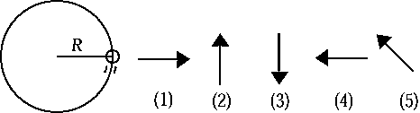
The figure shows a top view of a ball on the end of a string traveling counterclockwise in a circular path. Assume that air resistance is negligible. The free-body diagram that best represents the net force acting on the ball is
A) 1 B) 2 C) 3 D) 4 E) 5
Explain your answer:

7.
The figure shows a top view of a ball on the end of a string traveling counterclockwise in a circular path. Assume that air resistance is negligible. The free-body diagram that best represents the acceleration of the ball is
A) 1 B) 2 C) 3 D) 4 E) 5
Explain your answer:

8. A car of mass 700 kg negotiates a curve of radius 30m.
a. What force causes the car to undergo centripetal motion?

b. What is the minimum coefficient of static friction between the tires and the road if the car is traveling at 20 m/s?

c. What is the maximum speed that the car can travel through the curve if the coefficient of friction is 0.89?

