Velocity and Acceleration of a Simple Harmonic Oscillator

The graph below shows the position vs. time for a simple harmonic oscillator.
x
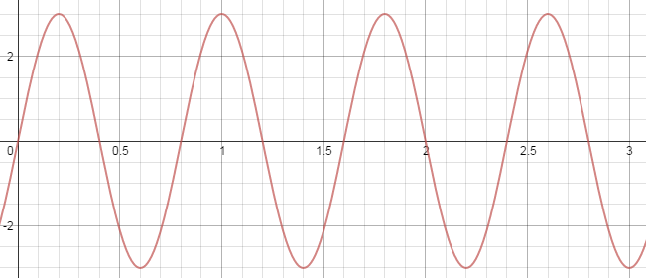
t

Draw the following on the graph above (use a pencil):

A big X at every time when the object returns to its original position (the position at time t = 0).
A big dot at every time the object comes to rest
A big square at every time the object has its greatest positive velocity
A big triangle at every time the object has its greatest negative velocity

On the velocity vs. time graph below, put a dot at zero at every time you put a dot on the first graph
Put a square at v_{max} at every time you put a square on the first graph
Put a triangle at v_{min} at every time you put a triangle on the first graph
Draw a smooth curve connecting all of these points
v_{max}
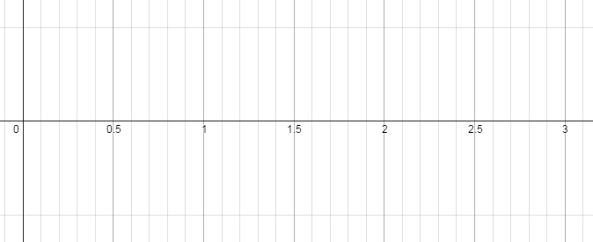
t
v_{min}

On the graph above, write “a = 0” at every point where the acceleration of the object is zero
Highlight all of the intervals where the object has a positive acceleration
Write “SD” next to all of the intervals where the object is slowing down
Go back to the first graph and write “a = 0” at the same times, indicating where the acceleration of the object is zero

What is true of the position when the object has zero velocity? Why is this?

What is true of the position when the object has zero acceleration? Why is this?

What is true of the position when the acceleration is positive? Why is this?

