Intro to Forces

1. The diagram shows a golf ball sitting on the group before Austin hits it.
On the diagram draw and label two forces which are equal in magnitude and opposite in direction in accordance with Newton’s Third Law of Motion.
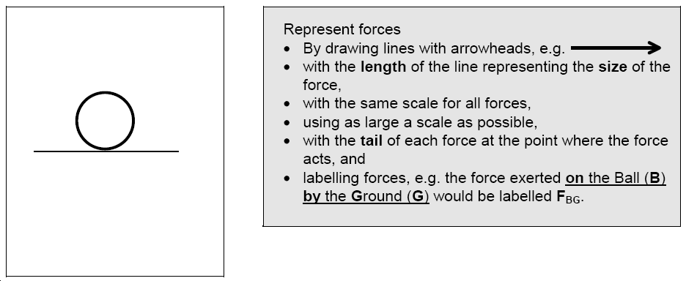

2. Before Austin hits the ball he thinks:
“According to Newton’s 3rd Law of Motion the club head will exert a force on the ball and the ball will exert an equal and opposite force on the club head. Therefore the net force is zero, and the ball should not move, but I know it will!

The diagram below shows the club head in contact with the ball as the club head swings through. Draw and label all the forces acting on the ball.

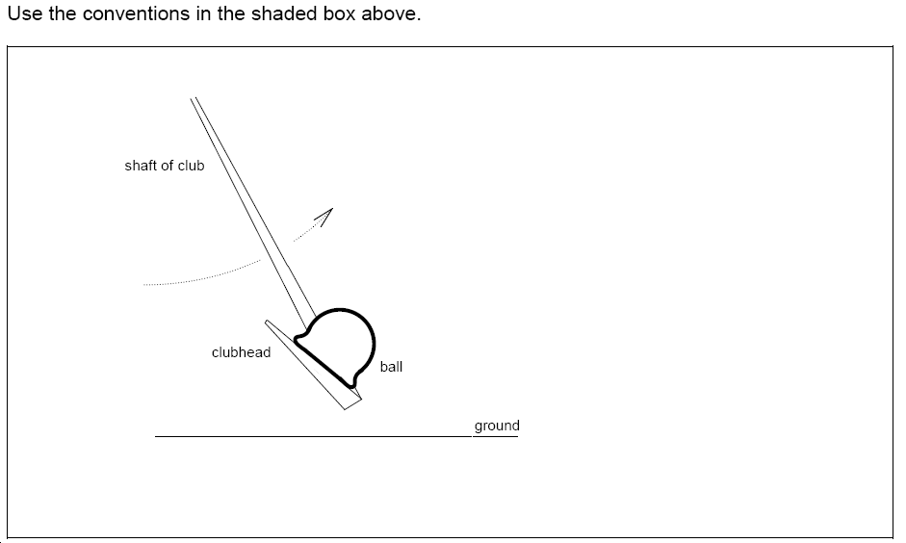

3. Can you see what is wrong with Austin’s thinking (above)?
Intro to Forces

1. The diagram shows a golf ball sitting on the group before Austin hits it.
On the diagram draw and label two forces which are equal in magnitude and opposite in direction in accordance with Newton’s Third Law of Motion.

2. Before Austin hits the ball he thinks:
“According to Newton’s 3rd Law of Motion the club head will exert a force on the ball and the ball will exert an equal and opposite force on the club head. Therefore the net force is zero, and the ball should not move, but I know it will!

The diagram below shows the club head in contact with the ball as the club head swings through. Draw and label all the forces acting on the ball.

3. Can you see what is wrong with Austin’s thinking (above)?

