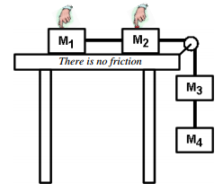
Force 2
1. Four masses are connected by ropes.
A. Since they are not on the table, which force cannot be acting on m₃ and m₄?

B. Below are the force diagrams for the masses. Label them as m₁, m₂, m₃ or m₄. Include a brief explanation for each.
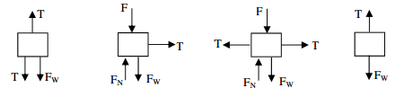

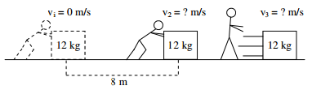
2. A man pushes on a 12 kg object for 10 seconds. It moves 8 m to the right while he is pushing it.
A. Calculate the acceleration of the mass.

B. Now, use F = ma to calculate the magnitude of the man’s force.

C. If the surface is frictionless, how does v₃ compare to v₂? Why?

D. If the surface has friction, how does v₃ compare to v₂? Why?

There are two major categories of forces: contact forces (when objects are actually touching) and field forces (forces that act at a distance and don’t need to be touching).
3. Contact or Field force?

A. ____ Tension
B. ____ Normal force
C. ____ Can cause accelerations
D. ____ Gravity
E. ____ * Electrostatic force
(like a balloon rubbed on hair)

Why this matters: Newton’s Third Law: “For every force there is an equal and opposite force.” But this opposite force must be of the same type: contact forces oppose contact forces; field forces oppose field forces.
4. A box is sitting on a table.
A. What force opposes the normal force pushing up on the box? Why?

B. What force opposes the force of weight pulling down on the box? Why?
5. Two very small people are pulling a box. Identify the four shown forces as F_{f} (friction); T; F_{g}; F_{N}. The “Σ” symbol is sigma and means to add up all of the forces.
A. _____ F₁— the two men pulling WITH A ROPE.
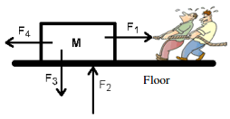
B. _____ F₂— the force pushing up by the floor.
C. _____ F₃— the force pulling down on the mass.
D. _____ F₄— the force trying to stop the mass from moving.
E. _____ Which force is in the negative x-direction?
F. _____ Which force is in the positive y-direction?
G. _____ Which force is in the positive x-direction?
H. _____ Which force is in the negative y-direction?

I. Which forces would be used in this equation: ΣF_{y} = ma_{y}?

J. Which forces would be used in this equation: ΣF_{x} = ma_{x}?

6. Two masses are attached by a rope that is threaded around a pulley, as shown. Identify the four shown forces as F_{f} (friction); T; F_{g}; F_{N}.
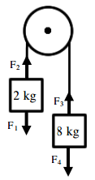
A. ____ F₁ (the force pulling down on the 2 kg mass).
B. ____ F₂ (the force of the rope pulling up on the 2 kg mass).
C. ____ F₃ (the force pulling up on the 8 kg mass).
D. ____ F₄ (the force pulling down on the 8 kg mass).
E. Which two forces are equal? Why?
F. Calculate F₁.
G. Calculate F₄.
H. Which forces are y-direction forces?
I. Which forces are x-direction forces?
J. Which way will the system accelerate? Why?

K. Which force is bigger, F₂ or F₁? Why?

L. Which force is bigger, F₃ or F₄? Why?

M. Find the acceleration of the system.

7. A small child (m=40 kg) is standing on a scale in an elevator. Answer the following questions about the forces acting on the boy for each situation.
a. The elevator is moving at a constant velocity of 14 m/s. How does the normal force compare to the weight? Why?

b. The elevator is accelerating upward at 5 m/s². How does the normal force compare to the weight? Why?

c. The elevator is accelerating down at 5 m/s². How does the normal force compare to the weight? Why? Calculate the normal force.

d. The elevator is accelerating down at 10 m/s² (equal to the acceleration due to gravity). What is the normal force? Why?

8. What is the acceleration of the following system? What is the tension in the string?
10 kg
20 kg

9. What is the acceleration of the following system? What is the tension in each string?

12 kg

5 kg
20 kg

