Simple Harmonic Motion

Oscillatory Motion: motion that repeats at regular intervals. Example: uniform circular motion
Explain why uniform circular motion is oscillatory:

Simple Harmonic Motion: a special case of oscillatory motion where there is a restoring force on the object which is proportional to the displacement of the object. Example: a mass on a spring

Explain why a mass on a spring moves in simple harmonic motion:

Period (T): Time needed to complete one oscillation. This means that the object returns to its starting position while moving in the same direction.
For a mass on a spring: $T=2π\sqrt{\frac{m}{k}}$ (m = mass) (k = spring constant)
For a simple pendulum displaced to a small amplitude: $T=2π\sqrt{\frac{l}{g}}$ (l = length) (g = gravitational field)

Frequency (f): Number of oscillations completed each second; the inverse of the period.

$$f=\frac{1}{T} T= \frac{1}{f}$$
Exercises

1. A simple pendulum is made by tying a 0.2 kg mass from a string that is 1.2 m long.

a) What is the period of such a pendulum?

b) What effect would doubling the mass have on the period of the pendulum?

c) What effect would doubling the length of the string have on the period of the pendulum?

2. A mass of 0.2 kg is attached to a spring and set in simple harmonic motion. The mass completes 10 oscillations in 18 seconds.

a) What is the frequency of oscillation?

b) What is the spring constant of the spring?

3. The pictures below show an object of mass m which is attached to a spring and moving in simple harmonic motion. At time t = 0 s, the spring is compressed to its maximum compression and the object is at rest. The position x₀ designates the unstretched length of the spring. The positions A represent the maximum displacement from equilibrium of the object. Make right the positive direction. Turn to the next page and follow directions carefully.
x₀
-A
A
t = 0 s
x₀
-A
A
t = 0.25 s
x₀
-A
A
t = 0.5 s
x₀
-A
A
t = 0.75 s
x₀
-A
A
t = 1 s
x₀
-A
A
t = 1.25 s
x₀
-A
A
t = 1.5 s

a) What is the period of oscillation for this object (at what time will it return to its starting point)?

b) On each picture of the object in the left column, draw an arrow indicating the velocity of the object or indicate that it’s zero. Draw your arrows to scale.

c) On the picture below, combine all of the pictures into one motion diagram. Draw a dot diagram showing the position of the object at each 0.25 s interval. Then draw a dot in between each interval, showing the approximate location of the object. Remember, the dots will be further apart as the object speeds up.
x₀
-A
A
d) In the right column on the table, draw a free body diagram showing all of the forces on the object at each time. Draw your arrows to scale. Assume friction is negligible. Don’t neglect the vertical forces.

e) Underneath each picture, indicate the direction of the acceleration of the object by writing a = left, right, or zero. Remember, acceleration is in the same direction as the net force! Don’t just draw arrows or you’ll get it confused with the arrow you drew for the velocity.

f) On the graphs below, draw an energy bar chart showing the distribution of energy in the object – spring system at each time. Use what you know to determine the distribution of energy at t = 1.75 s. 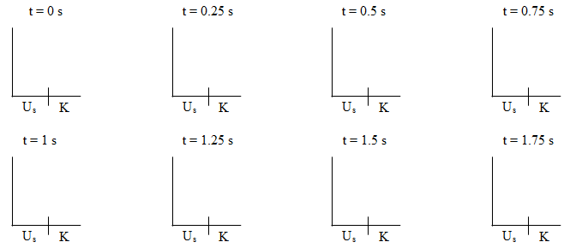
g) Information about the object is given in the table below:

Time (s) | Position (m) | Velocity (m/s) | Potential Energy (J) | Kinetic Energy (J) | Acceleration (m/s²)
0 | 4 | 0
0.25 | 2.83
0.5
0.75 | -2.83
1 | -4 | 0
1.25 | -2.83
1.5
1.75 | 2.83
2
Mass of object = 0.5 kg Spring Constant = 18 N/m

Follow the directions on the next page to fill in the missing information

i. Fill in the values for position based on the diagrams we have drawn.
ii. Use the equation $U_{s}=\frac{1}{2}kx^{2}$ to calculate the potential energy U_{s} in the spring at each time t.
iii. Use conservation of energy to determine the kinetic energy K at each time t.
iv. Use the equation $K=\frac{1}{2}mv^{2}$to calculate the velocity v of the object at each time t (look back to your diagrams to decide the sign).
v. Use Hooke’s Law, $F_{s}=-kx$ and Newton’s 2nd Law, $a=\frac{ΣF}{m}$to calculate the acceleration of the object at each time t.

h) Use the table to plot graphs of position vs. time, velocity vs. time, acceleration vs. time, and kinetic energy vs. time. Fill in the y-axis of each graph with the appropriate scale. Try to write an equation for each graph.
x (m)
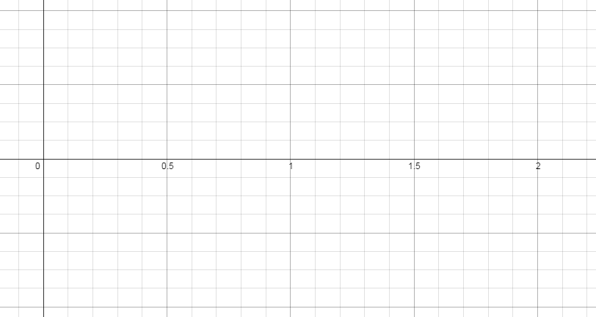
t (s)
v (m/s)
t (s)

a (m/s²)
t (s)

K (J)
t (s)

