Simple Harmonic Motion Review

1. What is the definition of a simple harmonic oscillator? Why are the two examples we studied considered simple harmonic oscillators?

2. What factors affect the period of a simple pendulum? What factors affect the period of a mass on a spring?

3. Why are some oscillators, such as a marble rolling in a U-shaped tube, not examples of simple harmonic motion?

4. A simple pendulum is constructed by hanging a 3 kg mass on the end of a 0.8 m long string. The pendulum is pulled back to a height of 0.2 m and released.
a) Calculate the period of such a pendulum.

b) At what time will the mass first reach its maximum velocity?

c) Calculate the maximum velocity of the pendulum bob.

d) How would your answer to each of the above change if the mass of the pendulum bob were doubled?

5. A 3 kg mass is attached to the end of an ideal spring of spring constant 100 N/m which is hanging vertically. The mass is pulled downward 0.2 m and released.
a) Calculate the period of the mass.

b) At what time will the mass first reach its maximum velocity?

c) Calculate the maximum velocity of the mass.

d) How would your answer to each of the above change if the mass were doubled?

e) What would the spring constant have to be to allow the 3 kg mass to oscillate 4 times per second?

6. A block of mass 5 kg is initially at rest next to an ideal spring of spring constant 1000 N/s, as shown in the diagram. A second block of mass 2 kg approaches the first block at a velocity of 35 m/s, colliding with it and sticking to it at time t = 0 s. After the collision, the blocks move together in simple harmonic motion. Friction on the system is negligible.

5 kg
2 kg
35 m/s

a) At what time after the collision will the two blocks first come to rest?

b) What is the maximum compression of the spring?

c) What is the position relative to the equilibrium position of the two blocks 1 s after the collision?

d) What is the maximum acceleration of the two blocks?

e) How much energy was lost during the collision?

7. The graph below shows the position of a particle which is in simple harmonic motion.
x (m)
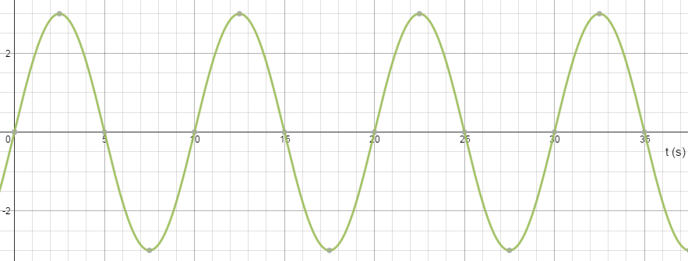

a) What is the period of the motion of this particle?

b) At what time will the particle first come to rest?

c) At what time will the particle first reach its maximum negative velocity?

d) At what time will the particle first reach its maximum positive acceleration?

e) At what time does the particle first have its maximum kinetic energy?

Assume that the particle is a mass of 2 kg which is oscillating on the end of an ideal spring. Calculate:
f) the spring constant of the spring

g) the magnitude of the maximum velocity of the mass

h) the magnitude of the maximum acceleration of the mass

i) On the graph below, plot the potential energy of the particle.

