**Rotation 3**

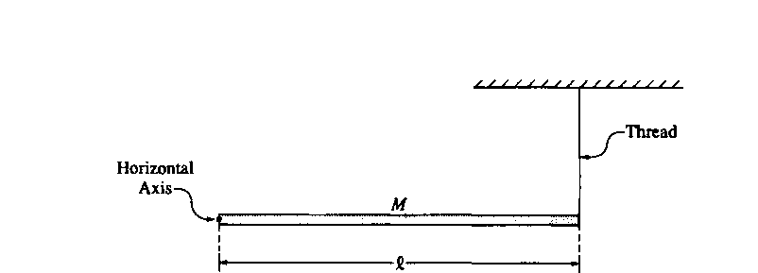

1. A rod of mass M is attached to a horizontal axis and a thread, as shown.
   1. What is the moment of inertia of the rod about the axis?
   2. Find the tension in the thread if the system remains at rest.
   3. The thread is cut and the rod begins to fall
      1. Find the initial angular acceleration of the rod about the horizontal axis.
      2. Find the initial linear acceleration of the center of the rod.
      3. Find the initial linear acceleration of the end of the rod.

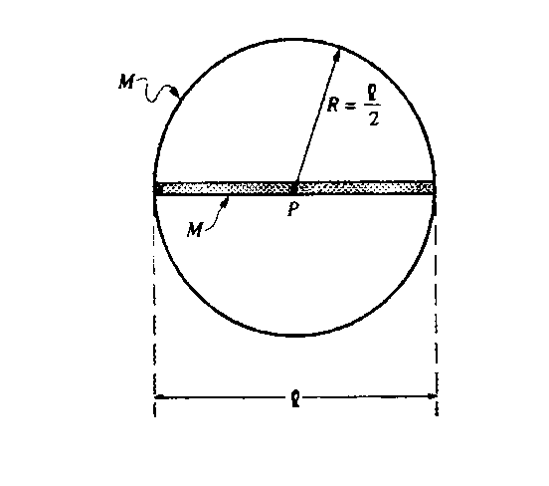

1. A ring of mass M=2kg has a rod of the same mass placed along a diameter. The length of the rod is 1.5 meters. An axis is placed through the center of the rod and the system is free to rotate.
   1. Find the rotational inertia of the ring-rod system.
   2. Several turns of string are wrapped tightly around the circumference of the hoop. The system is at rest when a cat, also of mass M, grabs the free end of the string and hangs vertically from it without swinging as it unwinds, causing the rod‑hoop assembly to rotate. Neglect friction and the mass of the string. You may need to draw a picture.
      1. What is the acceleration of the cat as it falls?
      2. What is the angular acceleration of the ring-rod system?
      3. What is the tension in the string?

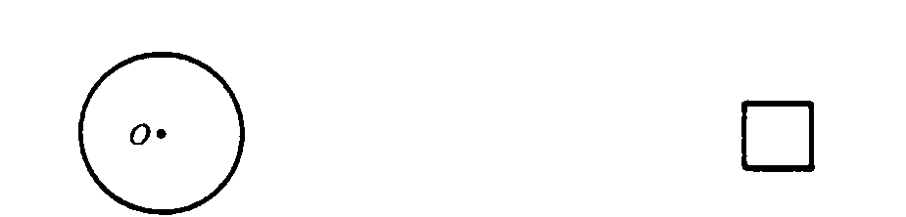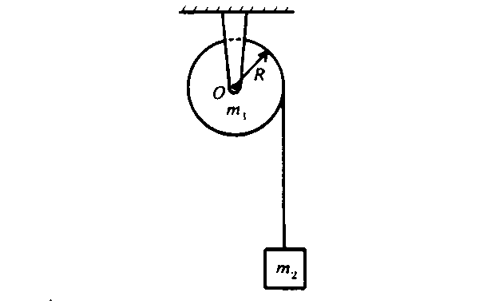

1. A uniform solid cylinder of mass m1 and radius *R* is mounted on frictionless bearings about a fixed axis through O. The moment of inertia of the cylinder about the axis is I = ½m1R2. A block of mass m2, suspended by a cord wrapped around the cylinder as shown above, is released at time t = 0.
   1. On the diagram above draw and identify all of the forces acting on the cylinder and on the block.
   2. In terms of ml, m2, *R.* and g, determine each of the following.
      1. The acceleration of the block
      2. The tension in the cord
      3. The angular momentum of the disk as a function of time t.
2. A cylinder rotates with constant angular acceleration about a fixed axis. The cylinder’s moment of inertial about the axis is 4 kg m2. At time t = 0 the cylinder is at rest. At time t = 2 seconds its angular velocity is 1 radian per second. What is the angular acceleration of the cylinder between t = 0 and t = 2 seconds?

(A) 0.5 radian/s² (B) 1 radian/s² (C) 2 radian/s² (D) 4 radian/s² (E) 5 radian/s²

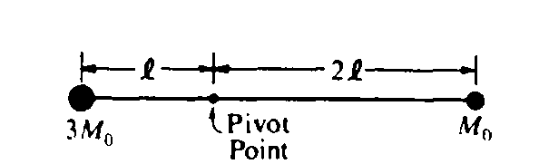

5. A light rigid rod with masses attached to its ends is pivoted about a horizontal axis as shown above. When released from rest in a horizontal orientation, the rod begins to rotate with an angular acceleration of magnitude

(A)  (B)  (C)  (D)  (E) 

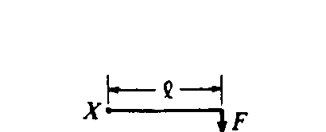

6. In which of the following diagrams is the torque about point O equal in magnitude to the torque about point X in the diagram above? (All forces lie in the plane of the paper.)

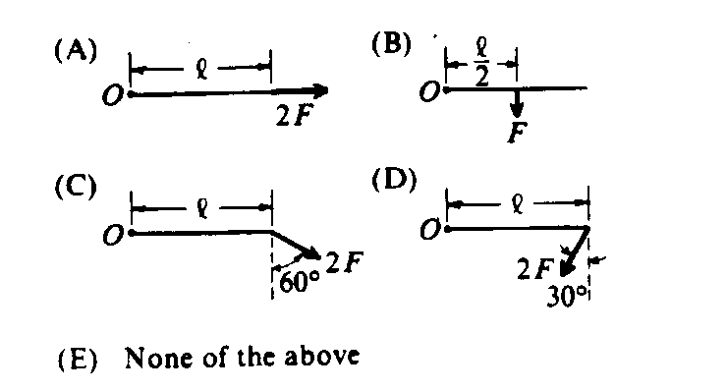

7. A turntable that is initially at rest is set in motion with a constant angular acceleration α. What is the angular velocity of the turntable after it has made one complete revolution?

(A)  (B)  (C)  (D) (E) 

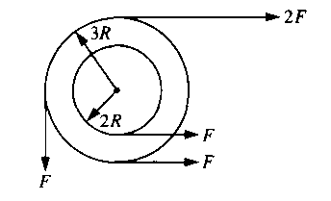

8. A system of two wheels fixed to each other is free to rotate about a frictionless axis through the common center of the wheels and perpendicular to the page. Four forces are exerted tangentially to the rims of the wheels, as shown above. The magnitude of the net torque on the system about the axis is

(A) zero (B) FR (C) 2FR (D) 5FR (E) 14FR