Rotation 4

1. How is angular momentum defined for a rotating object? What equation defines it? What units is it measured in?

2. How is angular momentum defined for an object which is not rotating (point particle moving in a straight line)? What equation defines it?

3. How is the angular momentum of a point particle a relative measurement? Explain completely.

4. How is angular momentum changed?

5. Explain why a figure skater rotates faster when she pulls her arms in closer to her body.

6. How does a diver control how fast he rotates as he falls through the air?

7. A student stands on a small frictionless platform which is free to rotate. He holds a bicycle wheel in his hands, oriented so that the axle of the wheel is vertical and the wheel itself is horizontal. He pushes the wheel clockwise, causing it to rotate rapidly. What change will be observed in the student? Explain completely in terms of momentum. Try it.

8. A frictionless platform has a mass of 40 kg and a radius of 2 m and can be considered a solid cylinder (I = ½MR²). The platform initially rotates at 10 rad/s counterclockwise.
a) Calculate the angular momentum of the platform.

b) A force of 30 N is exerted on the platform to the right, perpendicular to its radius at a point 1 m below its axis, over a period of 4 seconds. Explain how the angular velocity of the platform will change because of the force. What happens to the angular momentum of the platform during this time (both explain and calculate)?
2 m
1 m
30 N

c) How could the force be modified to create a greater change in angular momentum.

9. A bar of uniform density is secured at its center of mass and rotates with a clockwise angular velocity of 4 rad/s. The bar (I = MR²) has a mass of 8 kg and is 0.5 m long. When the rod is horizontal, a downward force F is applied for 0.2 s to the right edge of the bar, speeding it up to an angular velocity of 12 rad/s. Calculate the magnitude of the force F.
F

10. An arrow of mass 2 kg moves at a velocity of 20 m/s to the right (along the dashed line). Rank the angular momentum of the arrow about each of the points. Justify your ranking.
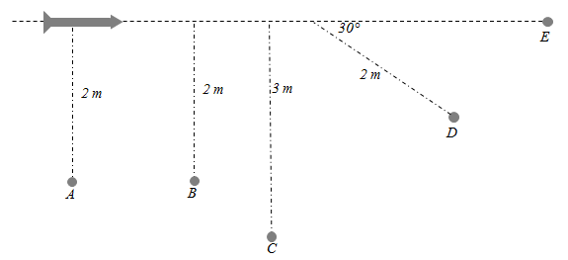

11. An arrow of mass 2 kg moves at a velocity of 20 m/s to the right. It strikes a wheel which is initially at rest and whose moment of inertia is 80 kg∙m/s and radius 0.8 m at a point along its edge and perpendicular to the radius. The arrow becomes imbedded in the wheel.
a) Calculate the angular velocity of the wheel after it is struck by the arrow (assume that the arrow doesn’t change the moment of inertia of the wheel. Indicate the direction of the angular velocity.
0.8 m
P

b) Does the linear momentum change as a result of the collision? If so, what force is responsible for changing the linear momentum?

c) How would the answer to a) be different if the path of the arrow were to be shifted downward (without changing the direction) such that the arrow struck the wheel at point P instead?

12. A platform (I = ½MR²) has a mass of 40 kg and a radius of 2 m and can rotate without friction. A boy of mass 60 kg initially stands on the edge of the platform. The platform rotates counterclockwise at 10 rad/s.
a) Calculate the angular momentum of the platform – boy system.

b) The boy slowly walks to the center of the platform until he is straddling the axis and has zero angular momentum. What happens to the angular momentum of the boy-platform system? What happens to the angular velocity of the platform (explain and calculate)?

c) The platform is brought to rest and the boy returned to the edge. The boy then runs along the perimeter of the platform clockwise with a constant linear speed of 6 m/s. Calculate the angular velocity of the platform and indicate its direction when:

a) the boy is running b) just after the boy stops running

13. An experimental cannon is constructed out of a solid sphere with a small muzzle on its top, which launches the cannon ball perpendicular to the sphere’s radius as shown below. The sphere has a moment of inertia of 100 kg∙m/s and a radius of 1.5 m. After launching the cannon ball (mass 2 kg) the sphere rotates at 2 rad/s about its center. Calculate the velocity of the cannon ball after launch.
v

