Rotation 5

1. A wheel has a moment of inertia of 500 kg∙m².

a) How much rotational kinetic energy will it have if it is rotating at 25 rad/s?

b) What is its angular velocity when it has 2.25 x 10⁵ J or rotational kinetic energy?

2. A wheel has a mass of 0.5 kg and a radius of 0.25 m. It rolls such that the center of mass of the wheel has a velocity of 10 m/s.

a) Calculate the angular velocity of the wheel.

b) Calculate the translational kinetic energy of the wheel.

c) Calculate the rotational kinetic energy of the wheel.

d) Calculate the kinetic energy of the wheel by summing the two kinetic energies.

5. A solid, spherical marble of mass 0.2 kg and radius 0.05 m is set in a spring loaded projectile launcher. The spring inside the launcher has a spring constant of 1000 N/m and is compressed 0.25 m. Calculate the velocity of the marble immediately after it is launched assuming

a) the marble slides out of the launcher without rolling

b) the marble rolls without slipping out of the launcher

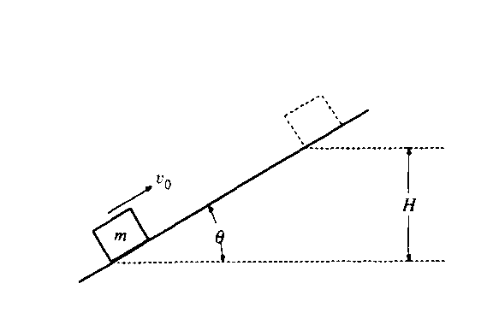

6. A block of mass m slides up the incline shown above with an initial speed v_{O} in the position shown.
a. If the incline is frictionless, determine the maximum height H to which the block will rise, in terms of the given quantities and appropriate constants.

b. If the incline is rough with coefficient of sliding friction μ, determine the maximum height to which the block will rise.

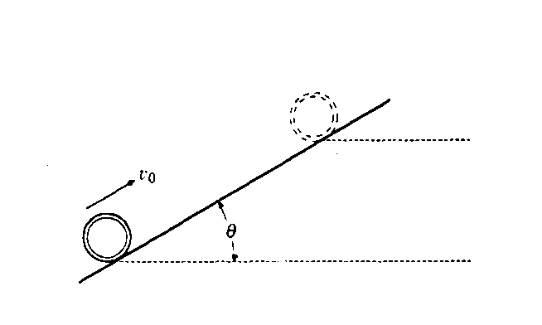
A thin hoop of mass m and radius R moves up the incline shown above with an initial speed v_{O} in the position shown.
c. If the incline is rough and the hoop rolls up the incline without slipping, determine the maximum height to which the hoop will rise.

d. If the incline is frictionless, determine the maximum height to which the hoop will rise.

