**Wave Interference**

AP Physics 1

a) Draw the resulting wave when:

i. each of the following pairs of wave pulses are overlapped ii. after the waves are overlapped

b) Indicate if the interference is constructive or destructive

|  |  |
| --- | --- |
|  |  |
|  |  |

The picture below shows two identical transverse wave pulses of amplitude *A* and wavelengthλ travelling towards each other on a string at time t = 0. The dashed line represents the equilibrium position of the string. P and Q designate specific points on the string, where P is directly between the wave pulses and Q is 2λ to the right of P.

P

Q

a) On the figure below, draw the shape of the string at the instant when the pulses overlap by λ.

P

Q

b) On the figure below, sketch a graph of displacement vs. time for point P, from time t = 0 until time t = t1, when the pulses no longer overlap.

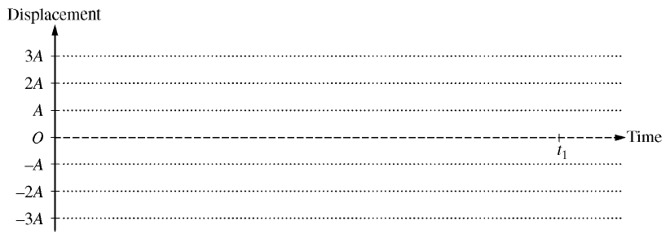

c) On the figure below, sketch a graph of displacement vs. time for point Q, from time t = 0 until time t = t1, when the pulses no longer overlap.

