Angular Momentum 1

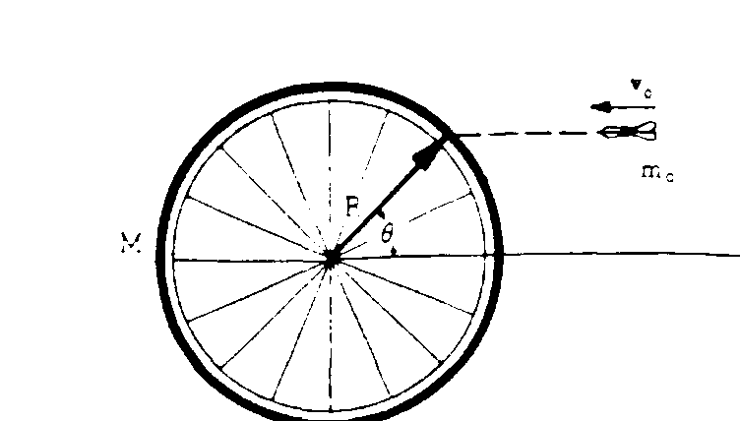
View From Above

1975M2. A bicycle wheel of mass M (assumed to be concentrated at its rim) and radius R is mounted horizontally so it may turn without friction on a vertical axle. A dart of mass mo is thrown with velocity vo as shown above and sticks in the tire.
- Will linear momentum be conserved in this collision? Why or why not?

- Will angular momentum be conserved in this collision? Why or why not?

- What is the initial angular momentum of the dart?

- What is the moment of inertia of the wheel after the dart has stuck to it?

- What is the angular velocity of the wheel after the dart has stuck into it?

1998M2. A space shuttle astronaut in a circular orbit around the Earth has an assembly consisting of two small dense spheres, each of mass m, whose centers are connected by a rigid rod of length l and negligible mass. The astronaut also has a device that will launch a small lump of clay of mass m at speed v0 . Express your answers in terms of m, v0 l. and fundamental constants.
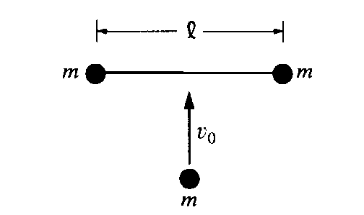
a. Initially, the assembly is "floating" freely at rest relative to the cabin, and the astronaut launches the clay lump so that it perpendicularly strikes and sticks to the midpoint of the rod, as shown above.
i. Will linear momentum be conserved in the collision?

ii. Will angular momentum be conserved? Is there any angular momentum?

iii. Find the final velocity and final angular velocity of the rod after the collision?

iv. Determine the change in kinetic energy as a result of the collision.

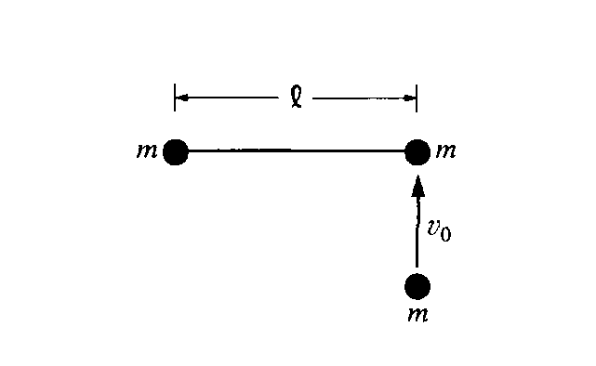

b. The assembly is brought to rest, the clay lump removed, and the experiment is repeated as shown above, with the clay lump striking perpendicular to the rod but this time sticking to one of the spheres of the assembly.
i. Determine the distance from the left end of the rod to the center of mass of the system (assembly and clay lump) immediately after the collision. (Assume that the radii of the spheres and clay lump are much smaller than the separation of the spheres.)

ii. On the figure above, indicate the direction of the motion of the center of mass immediately after the
collision.

iii. Determine the speed of the center of mass immediately after the collision.

iv. Determine the angular speed of the system (assembly and clay lump) immediately after the collision.

v. Will the change in kinetic energy for this collision be more or less than the change in kinetic energy for the previous collision?

