Capacitance 2

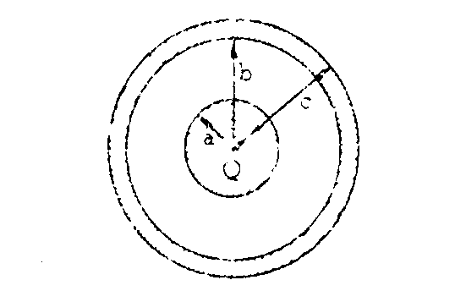
1981E1. A conducting sphere of radius a and charge Q is surrounded by a concentric conducting shell of inner radius b and outer radius c as shown above. The outer shell is first grounded; then the grounding wire is removed.
a. Using Gauss’s law, determine the electric field in the region a < r < b, where r is the distance from the center of the inner sphere.

b. Develop an expression for the capacitance C_{o} of the system of the two spheres.

A liquid dielectric with a dielectric constant of 4 is then inserted in the space between the conducting spheres and the shell, filling half of the space as shown below.
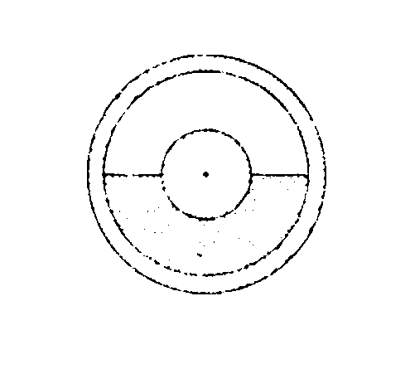
c. Determine the capacitance C of the system in terms of C_{o.}

