Electrostatics 3

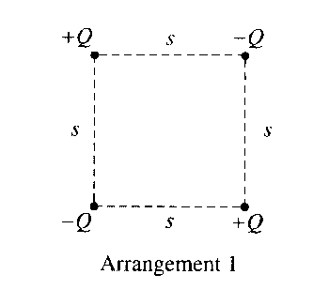
1. Four charged particles are held fixed at the corners of a square of side s. All the charges have the same magnitude Q, but two are positive and two are negative. In Arrangement 1, shown above, charges of the same sign are at opposite corners. Express your answers to parts (a) and (b) in terms of the given quantities and fundamental constants.
a. For Arrangement 1, determine the following.
i. The electrostatic potential at the center of the square

ii. The magnitude of the electric field at the center of the square

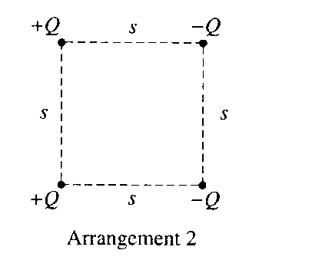
The bottom two charged particles are now switched to form Arrangement 2, shown above, in which the positively charged particles are on the left and the negatively charged particles are on the right.
b. For Arrangement 2, determine the following.
i. The electrostatic potential at the center of the square

ii. The magnitude of the electric field at the center of the square

c. In which of the two arrangements would more work be required to remove the particle at the upper right
corner from its present position to a distance a long way away from the arrangement? Justify your
answer.

_________ Arrangement 1 ___________ Arrangement 2

2. Three particles, A, B, and C, have equal positive charges Q and are held in place at the vertices of an equilateral triangle with sides of length f, as shown in the figures below. The dotted lines represent the bisectors for each side. The base of the triangle lies on the x-axis, and the altitude of the triangle lies on the y-axis.
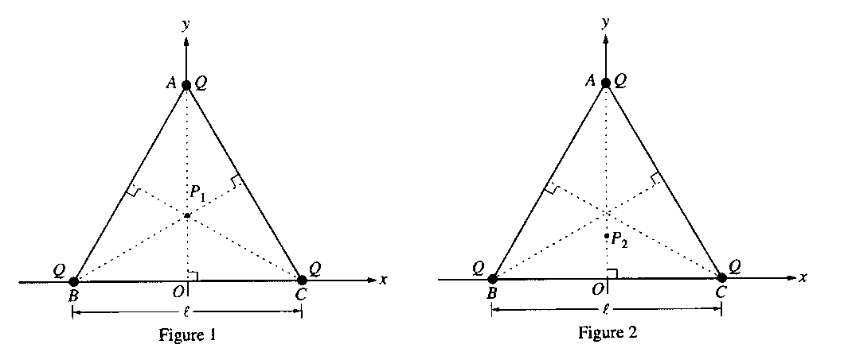
a. Write a general expression for the electric potential V at any point on the y-axis inside the triangle in terms of Q, l, and y.

b. Describe how the answer to part (a) could be used to determine the y-coordinates of points P₁ and P₂ at which the electric field is zero. (You do not need to actually determine these coordinates.)

3. The electric field E just outside the surface of a charged conductor is
(A) directed perpendicular to the surface (B) directed parallel to the surface
(C) independent of the surface charge density (D) zero (E) infinite

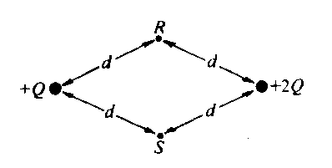
4. Points R and S are each the same distance d from two unequal charges, +Q and +2Q, as shown above. The work required to move a charge -Q from point R to point S is
(A) dependent on the path taken from R to S (B) directly proportional to the distance between R and S
(C) positive ( D) zero (E) negative

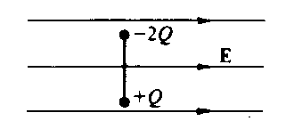
5. A rigid insulated rod, with two unequal charges attached to its ends, is placed in a uniform electric field E as shown above. The rod experiences a
(A) net force to the left and a clockwise rotation
(B) net force to the left and a counterclockwise rotation
(C) net force to the right and a clockwise rotation
(D) net force to the right and a counterclockwise rotation
(E) rotation, but no net force

Questions 6-7
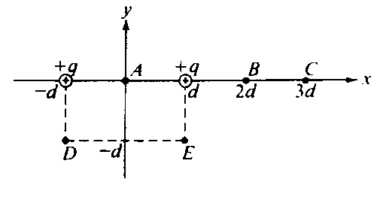
Two positive charges of magnitude q are each a distance d from the origin A of a coordinate systen. as shown above.

6. At which of the following points is the electric field least in magnitude?
(A) A (B) B (C) C (D) D (E) E

7. At which of the following points is the electric potential greatest in magnitude?
(A) A (B) B (C) C (D) D (E) E

