Electrostatics 4
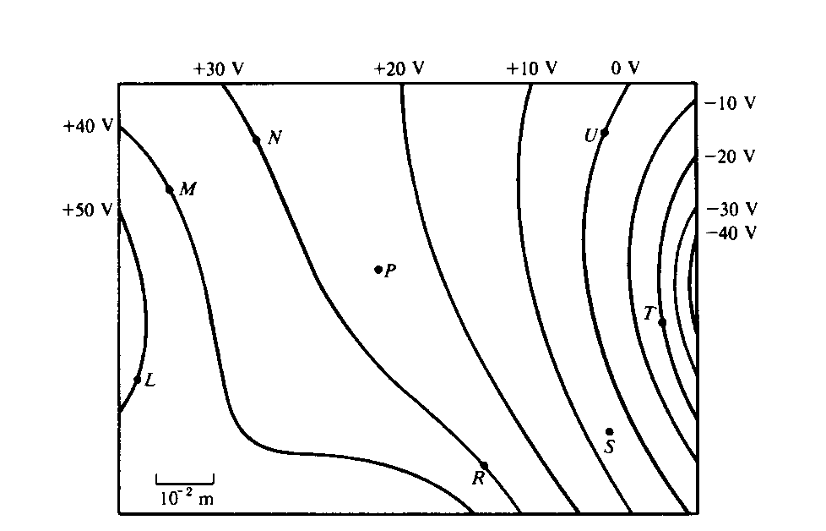

1. Three point charges produce the electric equipotential lines shown on the diagram above.
a. Draw arrows at points L, N. and U on the diagram to indicate the direction of the electric field at these points.
b. At which of the lettered points is the electric field E greatest in magnitude? Explain your reasoning.

c. Compute an approximate value for the magnitude of the electric field E at point P.

d. Compute an approximate value for the potential difference, V_{M} - V_{S}, between points M and S.

e. Determine the work done by the field if a charge of +5x10⁻¹² coulomb is moved from point M to point R.

f. If the charge of +5x10⁻¹² coulomb were moved from point M first to point S, and then to point R, would the answer to (e) be different, and if so, how?

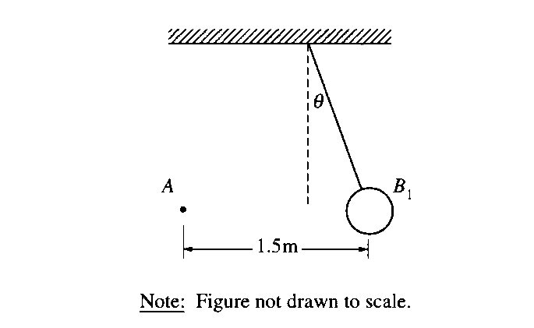
2. The small sphere A in the diagram above has a charge of 120 μ C. The large sphere B₁ is a thin shell of nonconducting material with a net charge that is uniformly distributed over its surface. Sphere B₁ has a mass of 0.025 kg, a radius of 0.05 m, and is suspended from an uncharged, nonconducting thread. Sphere B₁ is in equilibrium when the thread makes an angleθ = 20° with the vertical. The centers of the spheres are at the same vertical height and are a horizontal distance of 1.5 m apart, as shown.
a. Calculate the charge on sphere B₁.

b. Suppose that sphere B₁ is replaced by a second suspended sphere B₂ that has the same mass, radius, and charge, but that is conducting. Equilibrium is again established when sphere A is 1.5 m from sphere B₂ and their centers are at the same vertical height. State whether the equilibrium angle θ₂ will be less than, equal to, or greater than 20°. Justify your answer.

