Energy 4

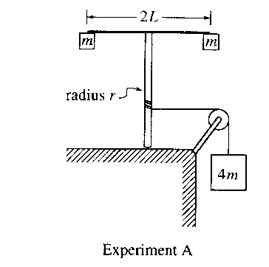
2001M3. A light string that is attached to a large block of mass 4m passes over a pulley with negligible rotational inertia and is wrapped around a vertical pole of radius r, as shown in Experiment A above. The system is released from rest, and as the block descends the string unwinds and the vertical pole with its attached apparatus rotates. The apparatus consists of a horizontal rod of length 2L, with a small block of mass m attached at each end. The rotational inertia of the pole and the rod are negligible.
a. Determine the rotational inertia of the rod-and-block apparatus attached to the top of the pole.

b. Determine the downward acceleration of the large block.

c. When the large block has descended a distance D, how does the instantaneous total kinetic energy of the three blocks compare with the value 4mgD ? Check the appropriate space below and justify your answer.

Greater than 4mgD Equal to 4mgD Less than 4mgD

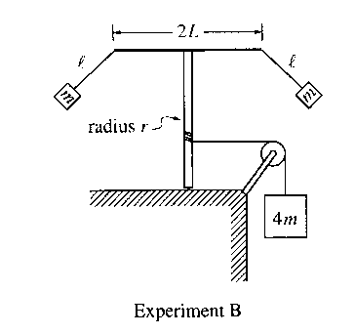
The system is now reset. The string is rewound around the pole to bring the large block back to its original location. The small blocks are detached from the rod and then suspended from each end of the rod, using strings of length l. The system is again released from rest so that as the large block descends and the apparatus rotates, the small blocks swing outward, as shown in Experiment B above. This time the downward acceleration of the block decreases with time after the system is released.
d. When the large block has descended a distance D, how does the instantaneous total kinetic energy of the three blocks compare to that in part c.? Check the appropriate space below and justify your answer.
Greater than Equal to Less than
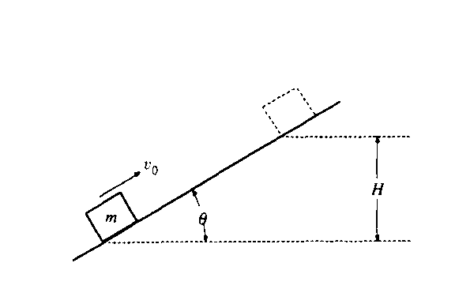
1990M2. A block of mass m slides up the incline shown above with an initial speed v_{O} in the position shown.
a. If the incline is frictionless, determine the maximum height H to which the block will rise, in terms of the given quantities and appropriate constants.

b. If the incline is rough with coefficient of sliding friction μ, determine the maximum height to which the block will rise in terms of H and the given quantities.

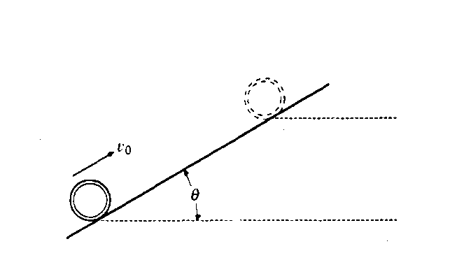
A thin hoop of mass m and radius R moves up the incline shown above with an initial speed v_{O} in the position shown.
c. If the incline is rough and the hoop rolls up the incline without slipping, determine the maximum height to which the hoop will rise in terms of H and the given quantities.

d. If the incline is frictionless, determine the maximum height to which the hoop will rise in terms of H and the given quantities.

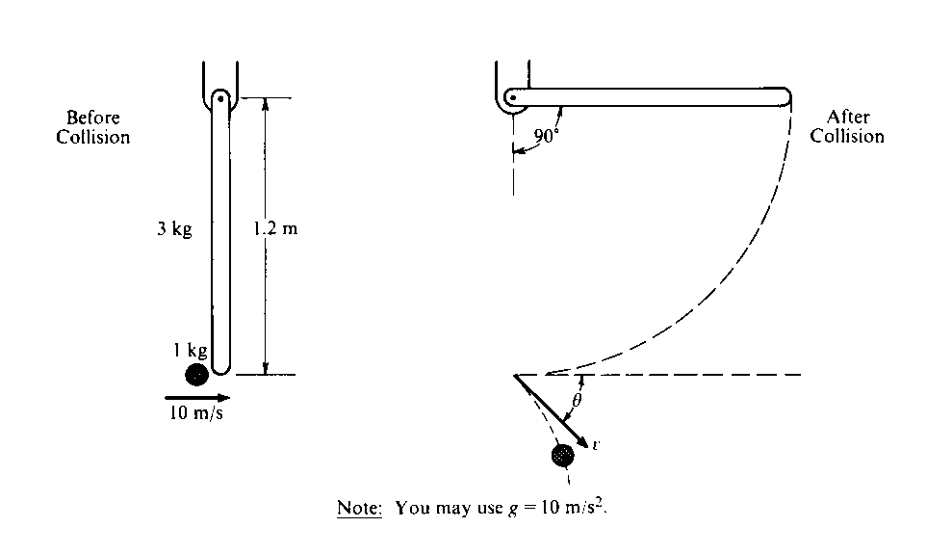
1987M3. A l.0-kilogram object is moving horizontally with a velocity of 10 meters per second, as shown above, when it makes a glancing collision with the lower end of a bar that was hanging vertically at rest before the collision. For the system consisting of the object and bar, linear momentum is not conserved in this collision, but kinetic energy is conserved. The bar, which has a length l of 1.2 meters and a mass m of 3.0 kilograms, is pivoted about the upper end. Immediately after the collision the object moves with speed v at an angle θ relative to its original direction. The bar swings freely, and after the collision reaches a maximum angle of 90° with respect to the vertical. The moment of inertia of the bar about the pivot is I_{bar} = ml²/3 Ignore all friction.
a. Determine the angular velocity of the bar immediately after the collision.

b. Determine the speed v of the l-kilogram object immediately after the collision.

c. Determine the magnitude of the angular momentum of the object about the pivot just before the collision.

d. Determine the angle θ.

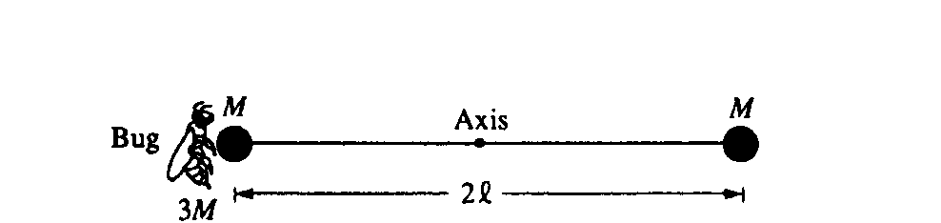
1992M2. Two identical spheres, each of mass M and negligible radius, are fastened to opposite ends of a rod of negligible mass and length 2l. This system is initially at rest with the rod horizontal, as shown above, and is free to rotate about a frictionless, horizontal axis through the center of the rod and perpendicular to the plane of the page. A bug, of mass 3M, lands gently on the sphere on the left. Assume that the size of the bug is small compared to the length of the rod. Express your answers to all parts of the question in terms of M, l, and physical constants.
a. Determine the torque about the axis immediately after the bug lands on the sphere.

b. Determine the angular acceleration of the rod-spheres-bug system immediately after the bug lands.

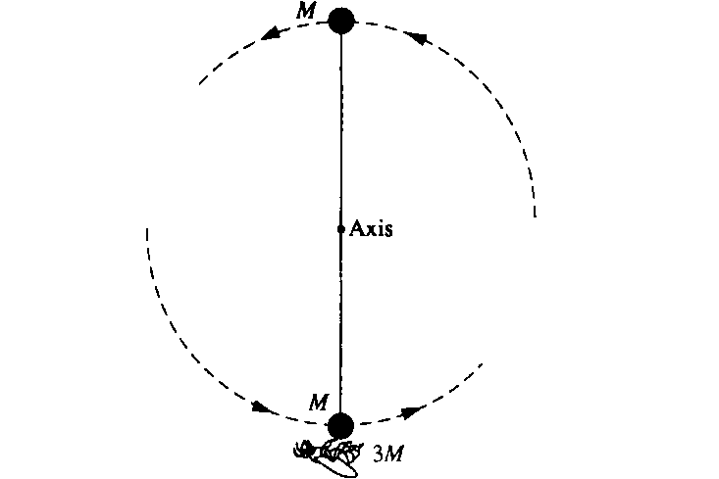

The rod-spheres-bug system swings about the axis. At the instant that the rod is vertical, as shown above, determine each of the following.
c. The angular speed of the bug

d. The angular momentum of the system

e. The magnitude and direction of the force that must be exerted on the bug by the sphere to keep the bug from being thrown off the sphere
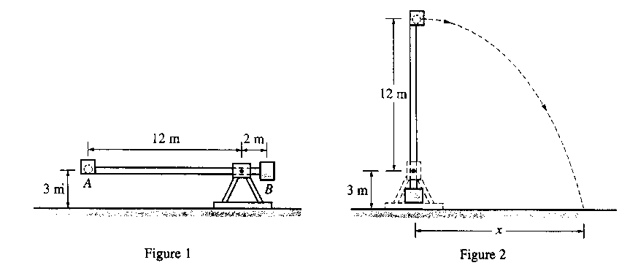
2003 Mech. 3.
Some physics students build a catapult, as shown above. The supporting platform is fixed firmly to the ground. The projectile, of mass 10 kg, is placed in cup A at one end of the rotating arm. A counterweight bucket B that is to be loaded with various masses greater than 10 kg is located at the other end of the arm. The arm is released from the horizontal position, shown in Figure 1, and begins rotating. There is a mechanism (not shown) that stops the arm in the vertical position, allowing the projectile to be launched with a horizontal velocity as shown in Figure 2.
(a) The students load five different masses in the counterweight bucket, release the catapult, and measure the resulting distance x traveled by the 10 kg projectile, recording the following data.
 | Mass (kg) | 100 | 300 | 500 | 700 | 900
 | X (m) | 18 | 37 | 45 | 48 | 51

i. The data are plotted on the axes below. Sketch a best-fit curve for these data points. 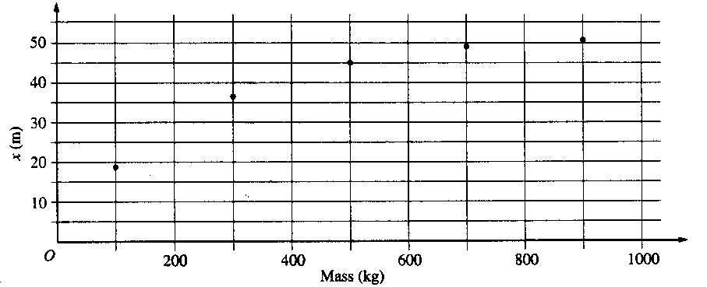
ii. Using your best-fit curve, determine the distance x traveled by the projectile if 250 kg is placed in the counterweight bucket.

(b) The students assume that the mass of the rotating arm, the cup, and the counterweight bucket can be neglected. With this assumption, they develop a theoretical model for x as a function of the counterweight mass using the relationship x = vt, where vx is the horizontal velocity of the projectile as it leaves the cup and t is the time after launch.
i. How many seconds after leaving the cup will the projectile strike the ground?

ii. Derive the equation that describes the gravitational potential energy of the system relative to the ground when in the position shown in Figure 1, assuming the mass in the counterweight bucket is M.

iii. Derive the equation for the velocity of the projectile as it leaves the cup, as shown in Figure 2.

(c)i. Complete the theoretical model by writing the relationship for x as a function of the counterweight mass using the results from (b)i and (b)iii.

ii. Compare the experimental and theoretical values of x for a counterweight bucket mass of 300 kg. Offer a reason for any difference.

