Energy 7: SHM
Tipler Ch 14: 35, 36, 40, 41, 42, 45, 46
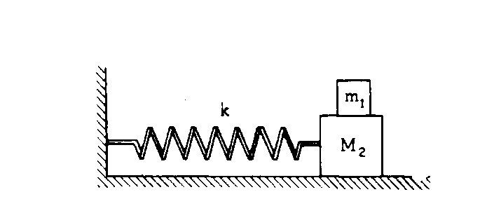
1980M1. A small mass m₁ rests on but is not attached to a large mass M₂ that slides on its base without friction.
The maximum frictional force between m₁ and M₂ is f. A spring of spring constant k is attached to the
large mass M₂ and to the wall as shown above.
a. Determine the maximum horizontal acceleration that M₂ may have without causing m₁ to slip.

b. Determine the maximum amplitude A for simple harmonic motion of the two masses if they are to move together, i.e., m₁ must not slip on M₂.

c. The two-mass combination is pulled to the right the maximum amplitude A found in part (b) and released. Describe the frictional force on the small mass m₁ during the first half cycle of oscillation.

d. The two-mass combination is now pulled to the right a distance of A' greater than A and released.
i. Determine the acceleration of m₁ at the instant the masses are released.

ii. Determine the acceleration of M₂ at the instant the masses are released.

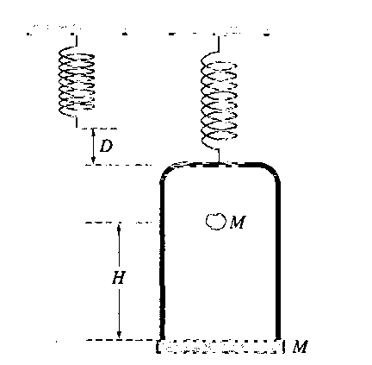
2003 Mech. 2.
An ideal spring is hung from the ceiling and a pan of mass M is suspended from the end of the spring, stretching it a distance D as shown above. A piece of clay, also of mass M, is then dropped from a height H onto the pan and sticks to it. Express all algebraic answers in terms of the given quantities and fundamental constants.
(a) Determine the speed of the clay at the instant it hits the pan.

(b) Determine the speed of the pan just after the clay strikes it.

(c) Determine the period of the simple harmonic motion that ensues.

(d) Determine the distance the spring is stretched (from its initial unstretched length) at the moment the speed of the pan is a maximum. Justify your answer.

(e) The clay is now removed from the pan and the pan is returned to equilibrium at the end of the spring. A rubber ball, also of mass M, is dropped from the same height H onto the pan, and after the collision is caught in midair before hitting anything else.
Indicate below whether the period of the resulting simple harmonic motion of the pan is greater than, less than, or the same as it was in part (c).
_______Greater than _______Less than _______The same as

Justify your answer.

