Gauss 2

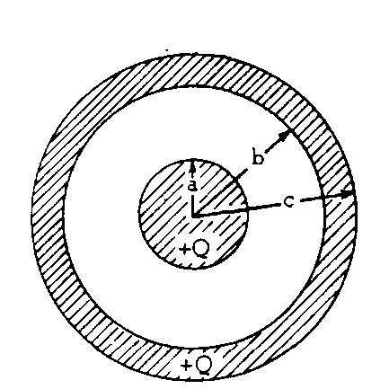
1. A solid conducting sphere of radius a is surrounded by a hollow conducting shell of inner radius b and outer radius c as shown above. The sphere and the shell each have a charge +Q. Express your answers to parts (a), (b) and (e) in terms of Q, a, b, c, and the Coulomb's law constant.
a. Using Gauss's law, derive an expression for the electric field magnitude at a < r < b, where r is the distance from the center of the solid sphere.

b. Write expressions for the electric field magnitude at r > c, b < r < c, and r < a. Full credit will be given for statements of the correct expressions. It is not necessary to show your work on this part.

c. On the axes below, sketch a graph of the electric field magnitude E vs. distance r from the center of
the solid sphere.
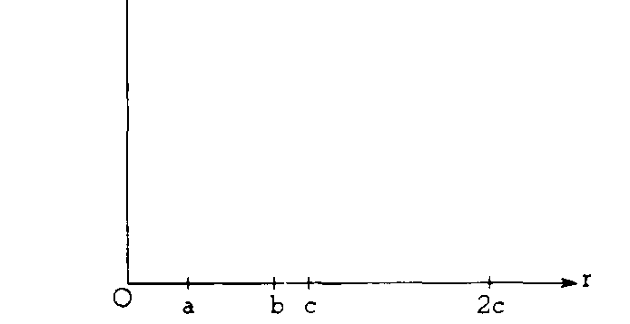
E
d. On the axes below, sketch a graph of potential V vs. distance r from the center of the solid sphere. (The potential V is zero at r = ∞.)
V

e. Determine the Potential at r = b.

1. A very long conducting rod of radius a has positive charge per unit length λ .
a. Use Gauss's law to derive an expression for the magnitude of the electric field E outside the rod.

b. The diagrams below represent cross sections of the rod. On these diagrams, sketch the following.
i. Several equipotential lines in the region r > a

ii. Several electric field lines in the region r > a
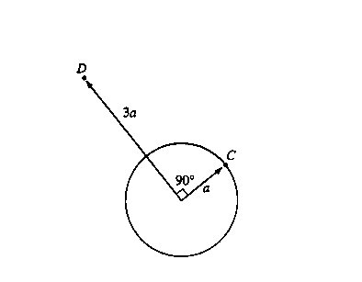

c. In the diagram above, point C is a distance a from the center of the rod (i.e., on the rod's surface), and point D is a distance 3a from the center on a radius that is 90° from point C. Determine the following.
i. The potential difference Vc - VD between points C and D

ii. The work required by an external agent to move a charge + Q from rest at point D to rest at point C

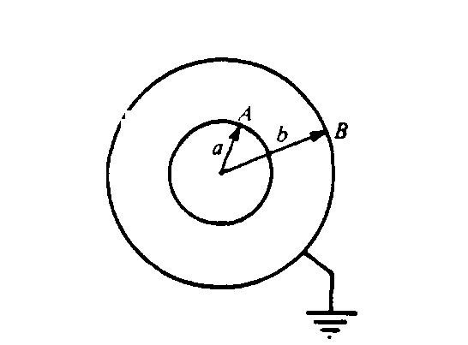
2. Two concentric, conducting spherical shells, A and B, have radii a and b, respectively, (a < b). Shell B is grounded, whereas shell A is maintained at a positive potential V_{o}
a. Using Gauss's law, develop an expression for the magnitude E of the electric field at a distance r from the center of the shells in the region between the shells. Express your answer in terms of the charge Q on the inner shell.

b. By evaluating an appropriate integral, develop an expression for the potential V_{o} in terms of Q, a, and b

