Gauss 3

1. A very long nonconducting rod of radius a has positive charge distributed throughout its volume. The charge distribution is cylindrically symmetric, and the total charge per unit length of the rod is λ .
a. Use Gauss's law to derive an expression for the magnitude of the electric field E outside the rod.

b. The diagrams below represent cross sections of the rod. On these diagrams, sketch the following.
i. Several equipotential lines in the region r > a

ii. Several electric field lines in the region r > a
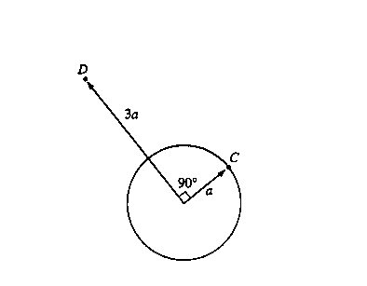

c. In the diagram above, point C is a distance a from the center of the rod (i.e., on the rod's surface), and point D is a distance 3a from the center on a radius that is 90° from point C. Determine the following.
i. The potential difference Vc - VD between points C and D

ii. The work required by an external agent to move a charge + Q from rest at point D to rest at point C
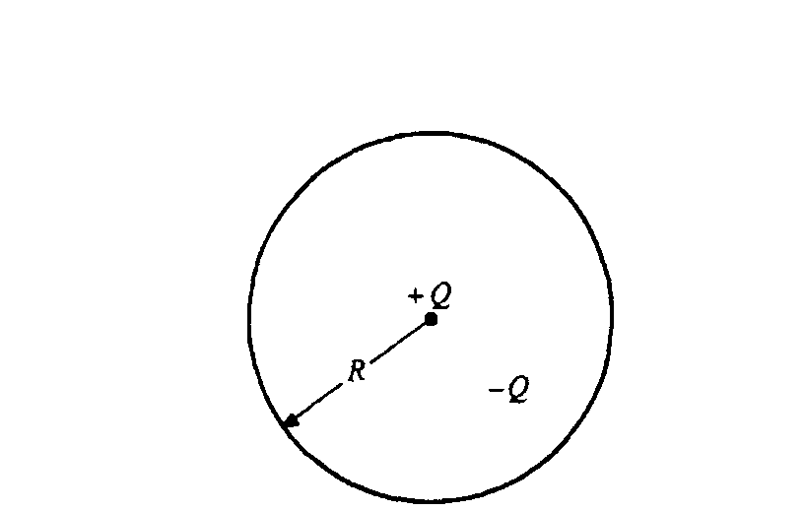
2. A negative charge - Q is uniformly distributed throughout the spherical volume of radius R shown above. A positive point charge + Q is at the center of the sphere. Determine each of the following in terms of the quantities given and fundamental constants.
a. The electric field E outside the sphere at a distance r > R from the center

b. The electric potential V outside the sphere at a distance r > R from the center

c. The electric field inside the sphere at a distance r < R from the center

d. The electric potential inside the sphere at a distance r < R from the center

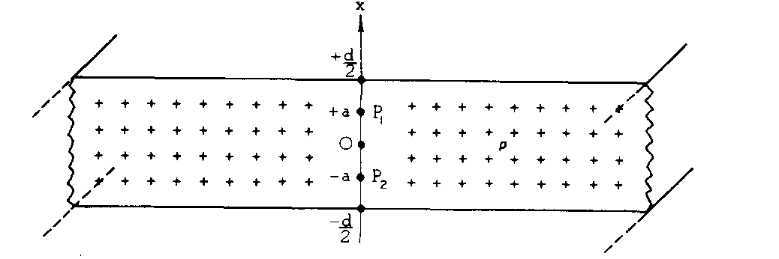
3. A slab of infinite length and infinite width has a thickness d. Point P₁ is a point inside the slab at x = a and point P₂ is a point inside the slab at x = -a. Consider the slab to be nonconducting with uniform charge per unit volume ρ as shown.
a. Sketch vectors representing the electric field E at points P₁ and P₂ on the following diagram.

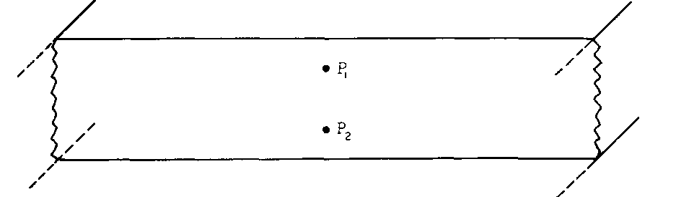

b. Use Gauss's law and symmetry arguments to determine the magnitude of E at point P_{l}.

