1988E1. The isolated conducting solid sphere of radius a shown above is charged to a potential V.
- Determine the charge on the sphere.

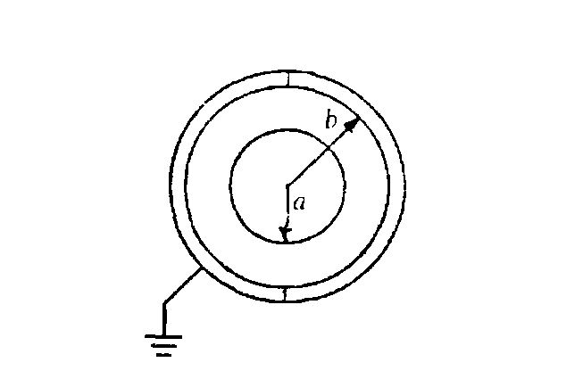
Two conducting hemispherical shells of inner radius b are then brought up and, without contacting the solid sphere are connected to form a spherical shell surrounding and concentric with the solid sphere as shown below The outer shell is then grounded.
b. By means of Gauss's law, determine the electric field in the space between the solid sphere and the shell at a distance r from the center.

c. Determine the potential of the solid sphere relative to ground.

d. Determine the capacitance of the system in terms of the given quantities and fundamental constants.
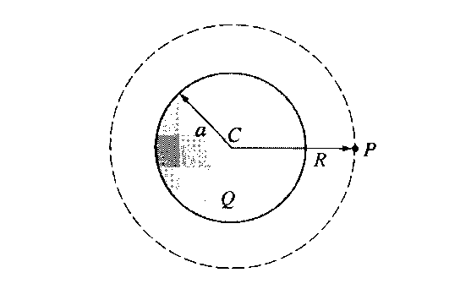
1997E2. A nonconducting sphere with center C and radius a has a spherically symmetric electric charge density. The total charge of the object is Q > 0.
a. Determine the magnitude and direction of the electric field at point P, which is a distance R > a to the right of the sphere's center.

- Determine the flux of the electric field through the spherical surface centered at C and passing through P.

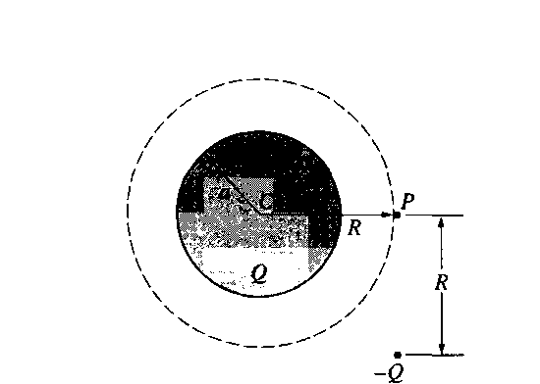

A point particle of charge -Q is now placed a distance R below point P. as shown above.
c. Determine the magnitude and direction of the electric field at point P.

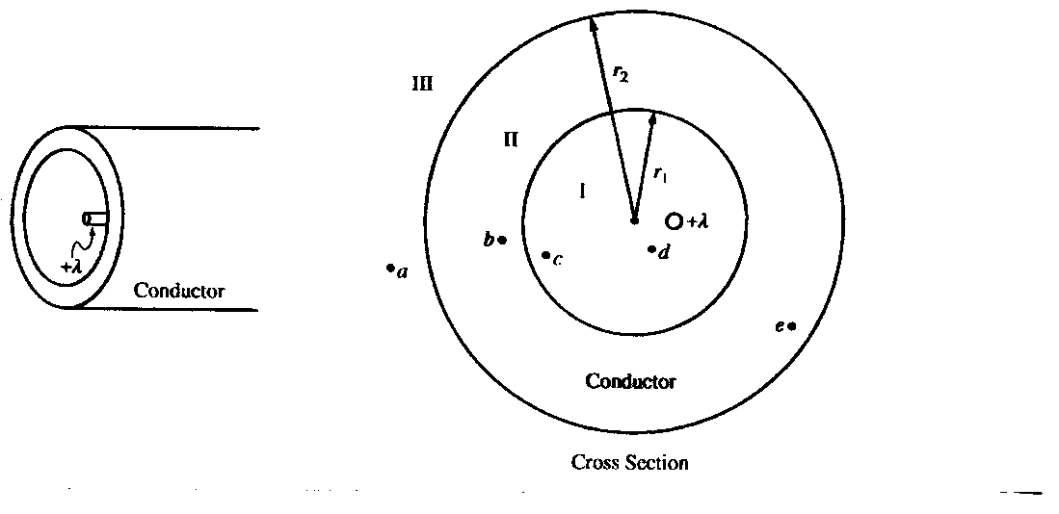
E&M. 1.
The figure above left shows a hollow, infinite, cylindrical, uncharged conducting shell of inner radius r1 and outer radius r2. An infinite line charge of linear charge density + is parallel to its axis but off center. An enlarged cross section of the cylindrical shell is shown above right.
(a) On the cross section above right,
i. sketch the electric field lines, if any, in each of regions I, II, and III and
ii. use + and - signs to indicate any charge induced on the conductor.
(b) In the spaces below, rank the electric potentials at points a, b, c, d, and e from highest to lowest (1 = highest potential). If two points are at the same potential, give them the same number.

——— Va ——— Vb ——— Vc ——— Vd ——— Ve

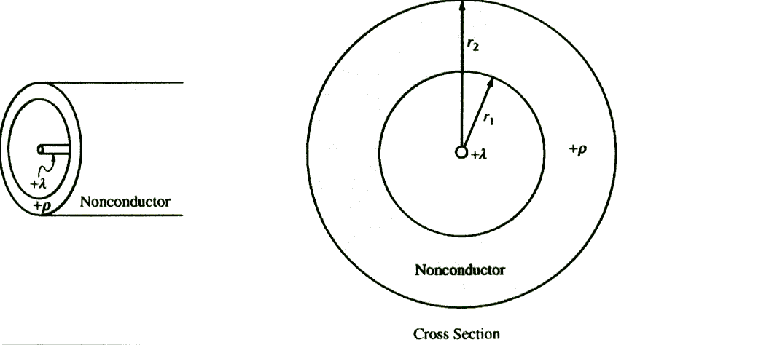

(c) The shell is replaced by another cylindrical shell that has the same dimensions but is nonconducting and carries a uniform volume charge density +. The infinite line charge, still of charge density +, is located at the center of the shell as shown above. Using Gauss's law, calculate the magnitude of the electric field as a function of the distance r from the center of the shell for each of the following regions. Express your answers in terms of the given quantities and fundamental constants.
i. r < r₁

ii.

iii. r > r₂

