**Gauss 6**

1. A spherically symmetric charge distribution has net positive charge *Q*0 distributed within a radius of *R*. Its electric potential *V* as a function of the distance *r* from the center of the sphere is given by the following.

 for *r* < *R*

 for *r* > *R*

Express all algebraic answers in terms of the given quantities and fundamental constants.

(a) For the following regions, indicate the direction of the electric field *E*(*r*) and derive an expression for its magnitude.

i. *r*<*R* ____ Radially inward ____ Radially outward

ii. *r*>*R* ____ Radially inward ____ Radially outward

(b) For the following regions, derive an expression for the enclosed charge that generates the electric field in that region, expressed as a function of *r*.

i. *r*<*R*

ii. *r*>*R*

(c) Is there any charge on the surface of the sphere (*r* = *R*)?

____ Yes ____ No

If there is, determine the charge. In either case, explain your reasoning.

(d) On the axes below, sketch a graph of the force that would act on a positive test charge in the regions *r*< *R* and *r*> *R*. Assume that a force directed radially outward is positive.

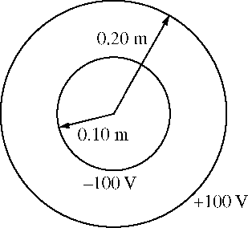

2. Two thin, concentric, conducting spherical shells, insulated from each other, have radii of 0.10 m and 0.20 m, as shown above. The inner shell is set at an electric potential of -100 V , and the outer shell is set at an electric potential of +100 V, with each potential defined relative to the conventional reference point. Let *Qi* and *Qo* represent the net charge on the inner and outer shells, respectively, and let *r* be the radial distance from the center of the shells. Express all algebraic answers in terms of *Qi* , *Qo* , *r*, and fundamental constants, as appropriate.

Using Gauss’s Law, derive an algebraic expression for the electric field *E*(*r*) for 0.10 m < *r* < 0.20 m.

a. Determine an algebraic expression for the electric field *E*(*r*) for *r* > 0.20 m.

b. Determine an algebraic expression for the electric potential *V*(*r*) for *r* > 0.20 m.

c. Using the numerical information given, calculate the value of the total charge *QT* on the two spherical shells (*QT* = *Qi* + *Qo*) .

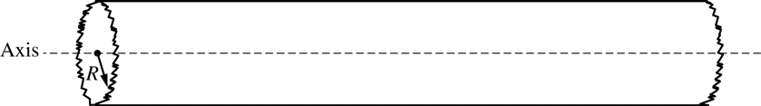

3. A very long, solid, nonconducting cylinder of radius *R* has a positive charge of uniform volume density ρ. A section of the cylinder far from its ends is shown in the diagram above. Let *r* represent the radial distance from the axis of the cylinder. Express all answers in terms of ρ, *R*, *r* , and fundamental constants, as appropriate.

a. Using Gauss’s law, derive an expression for the magnitude of the electric field at a radius *r* < *R*. Draw an appropriate Gaussian surface on the diagram.

b. Using Gauss’s law, derive an expression for the magnitude of the electric field at a radius *r* > *R*.

c. On the axes below, sketch the graph of electric field *E* as a function of radial distance *r* for *r* = 0 to *r* = 2*R*. Explicitly label any intercepts, asymptotes, maxima, or minima with numerical values or algebraic expressions, as appropriate.

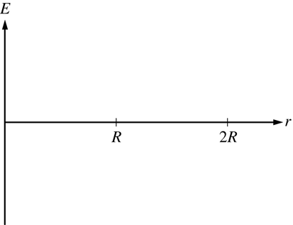

d. i. Derive an expression for the magnitude of the potential difference between *r =* 0 and *r = R* .

ii. Is the potential higher at *r* = 0 or *r* = *R* ?

*r* = 0  *r* = *R*

e.) The nonconducting cylinder is replaced with a conducting cylinder of the same shape and same linear charge density. On the axes below, sketch the electric field *E* as a function of *r* for *r =* 0 to *r = 2R*. Explicitly label any intercepts, asymptotes, maxima, or minima with numerical values or algebraic expressions, as appropriate.

