Kinematics 1
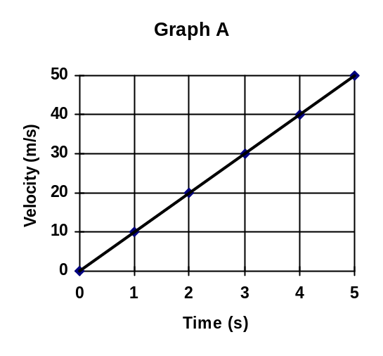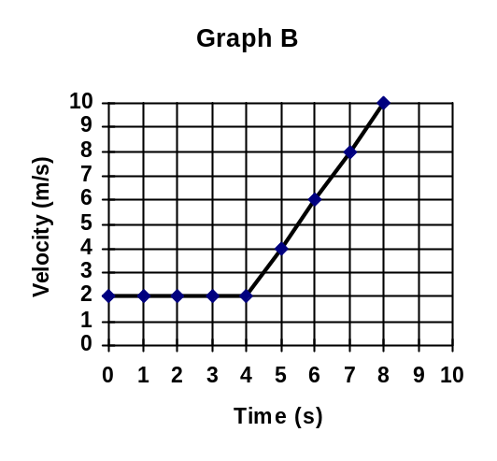Analyze the following velocity vs. time graphs and answer the questions that follow.

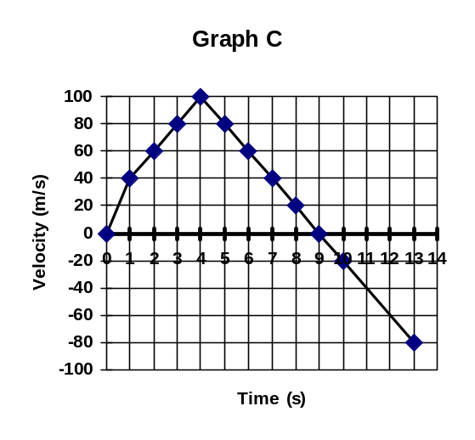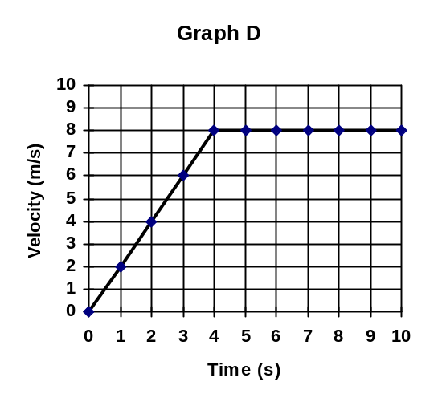

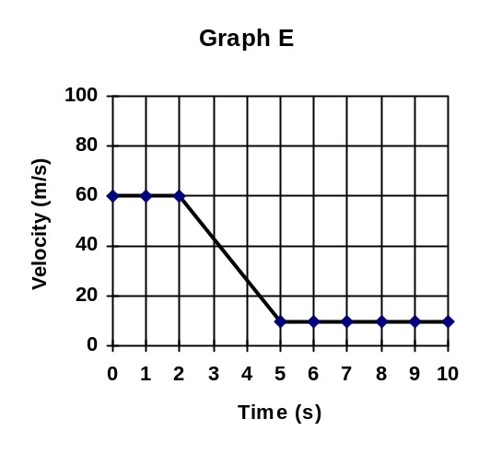
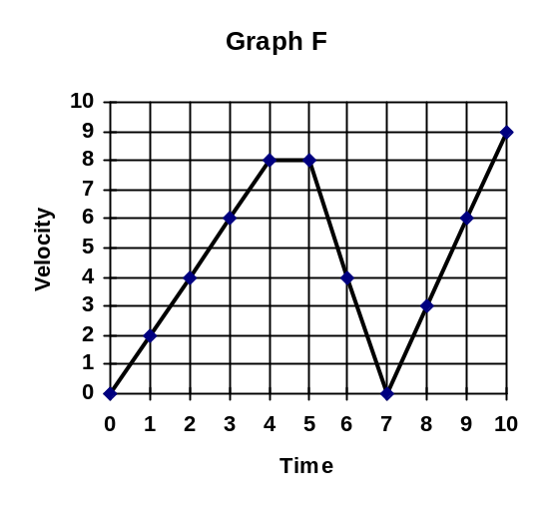

- Which of the graphs involve a time interval where the velocity of an object was held constant?

- Which of the graphs involve a time interval where the acceleration of an object was held constant?

- Calculate the acceleration of the object for any graph(s) you chose as answers to question 2. Show all work in the space provided .

- Which of the graphs involve an object that was negatively accelerating?

- Which of the graphs involve an object that came to a stop?

- Which of the graphs involve an object that changed direction?

- Analyze Graph F. For which of the time intervals was the object experiencing the greatest positive acceleration?

- Calculate the net displacement for the object in Graph B.

- Calculate the net displacement for the object in Graph D.

- Calculate the displacement for the object in Graph F for the time interval t = 0s to t = 4 s.

Complete the following series of graphs. For the displacement versus time graphs, construct the velocity versus time, and acceleration versus time graphs. For the velocity versus time graph construct the displacement versus time and acceleration versus time graph. Under each graph, make dots that represent the motion of the object.
1. 2. 3. 4.
d
t
v
t
a
t
d
t
v
t
a
t
d
t
v
t
a
t
d
t
v
t
a
t
5. 6. 7. 8.
d
t
v
t
a
t
d
t
v
t
a
t
d
t
v
t
a
t
d
t
v
t
a
t

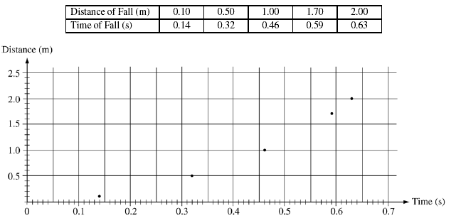

If only the variables D and t are used, what quantities should the student graph in order to produce a linear relationship between the two quantities?

__________________________ ______________________

On the graph paper below, linearize the data, label the axes, and draw your best fit line to the data. Write the equation of your best fit line.

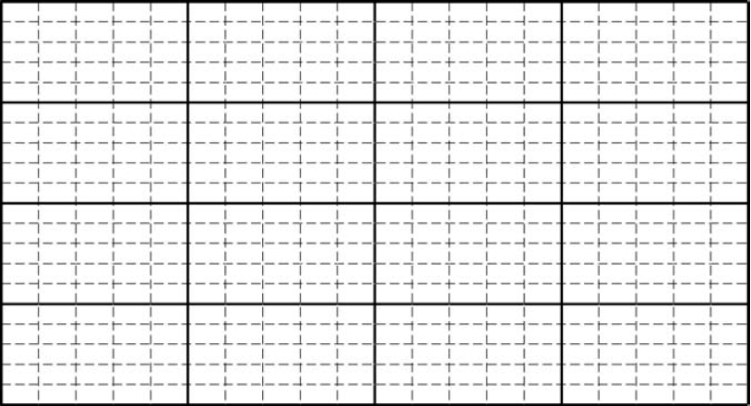
Use the slope of your best fit line to calculate the magnitude of the acceleration due to gravity in this experiment.

