Momentum 1



1. Two identical objects A and B of mass M move on a one-dimensional, horizontal air track. Object B initially moves to the right with speed vo. Object A initially moves to the right with speed 3vo, so that it collides with object B. Friction is negligible. Express your answers to the following in terms of M and vo.

a. Determine the total momentum of the system of the two objects.

b. A student predicts that the collision will be totally inelastic (the objects stick together on collision). Assuming this is true, determine the following for the two objects immediately after the collision.

i. The speed

ii. The direction of motion (left or right)

When the experiment is performed, the student is surprised to observe that the objects separate after the collision and that object B subsequently moves to the right with a speed 2.5vo .

c. Determine the following for object A immediately after the collision.

i. The speed

ii. The direction of motion (left or right)

d. Determine the kinetic energy dissipated in the actual experiment.

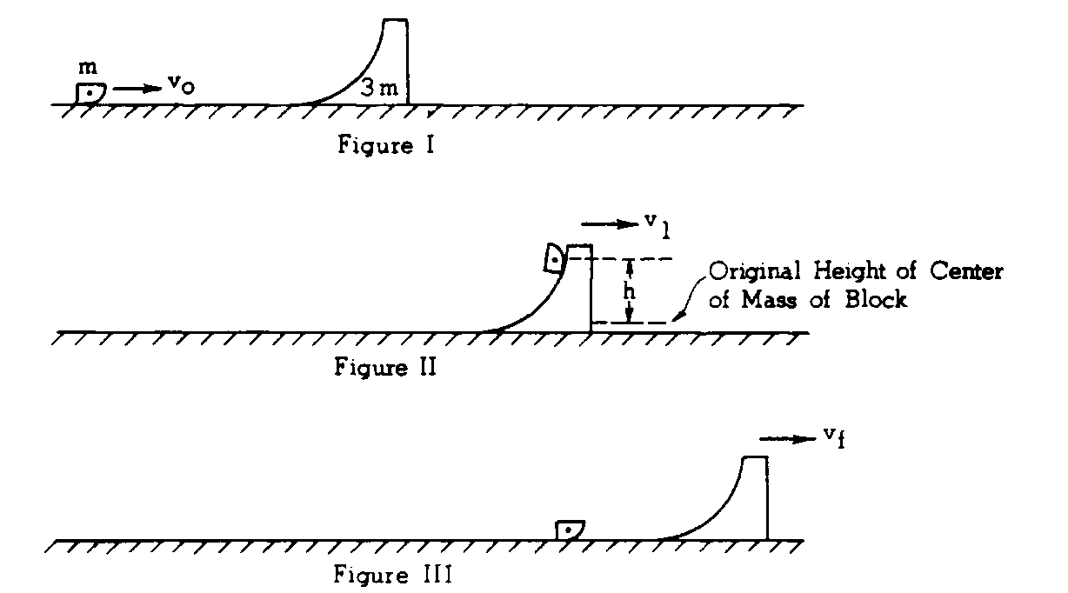

A block of mass m slides at velocity vo across a horizontal frictionless surface toward a large curved movable ramp of mass 3m as shown in Figure 1. The ramp, initially at rest, also can move without friction and has a smooth circular frictionless face up which the block can easily slide. When the block slides up the ramp, it momentarily reaches a maximum height as shown in Figure II and then slides back down the frictionless face to the horizontal surface as shown in Figure III.

a. Find the velocity v1 of the moving ramp at the instant the block reaches its maximum height.

b. To what maximum height h does the center of mass of the block rise above its original height?

c. Determine the final speed vf of the ramp and the final speed v' of the block after the block returns to the level surface. State whether the block is moving to the right or to the left.