Momentum 3

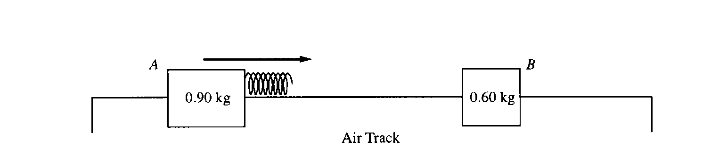

1. Two gliders move freely on an air track with negligible friction, as shown above. Glider A has a mass of 0.90 kg and glider B has a mass of 0.60 kg. Initially, glider A moves toward glider B, which is at rest. A spring of negligible mass is attached to the right side of glider A. Strobe photography is used to record successive positions of glider A at 0.10 s intervals over a total time of 2.00 s, during which time it collides with glider B.

The following diagram represents the data for the motion of glider A. Positions of glider A at the end of each 0.10s interval are indicated by the symbol A against a metric ruler. The total elapsed time t after each 0.50 s is also indicated.

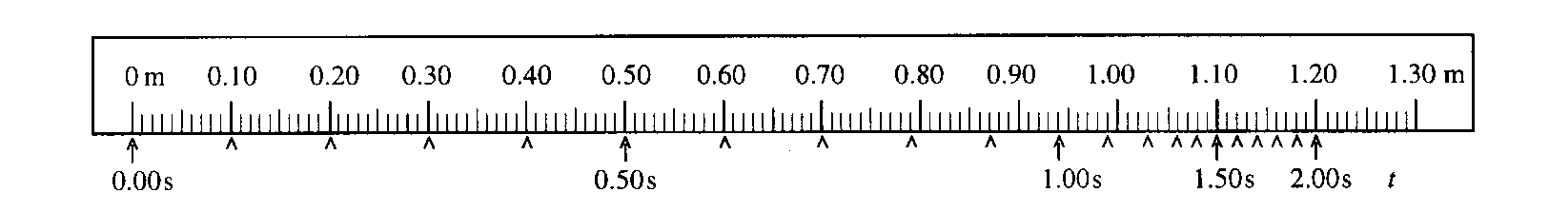a. Determine the average speed of glider A for the following time intervals.

i. 0.L0 s to 0.30 s ii. 0.90 s to 1.10 s iii. 1.70 s to 1.90 s

b. On the axes below, sketch a graph, consistent with the data above, of the speed of glider A as a function of time t for the 2.00 s interval.

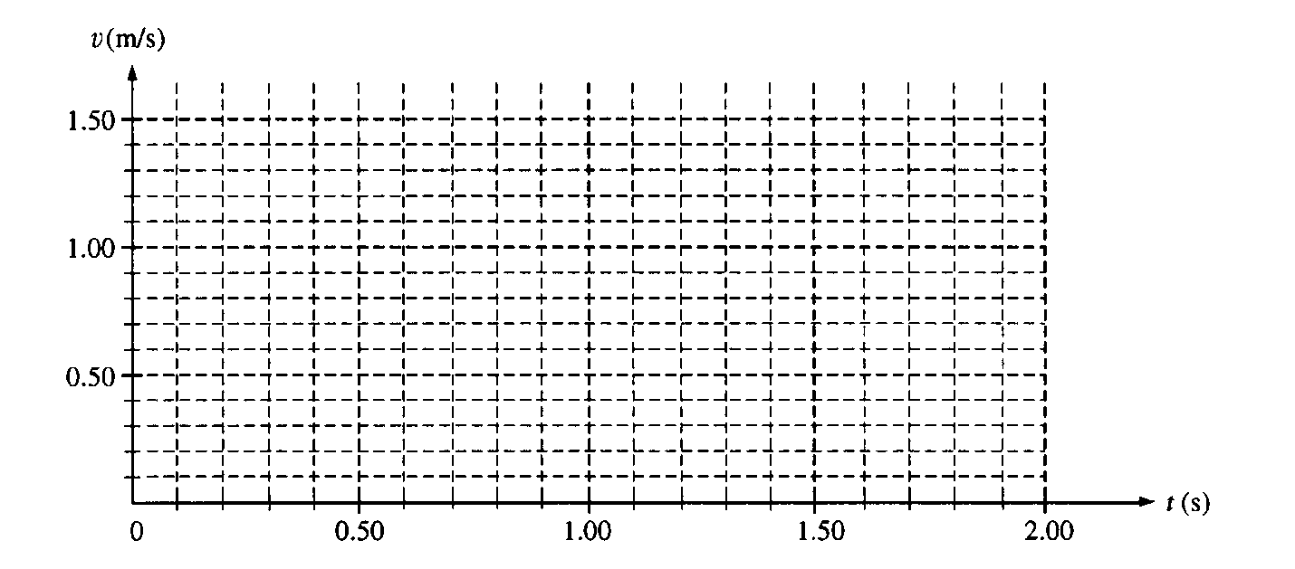

c. i. Use the data to calculate the speed of glider B immediately after it separates from the spring.

ii. On the axes below, sketch a graph of the speed of glider B as a function of time t.

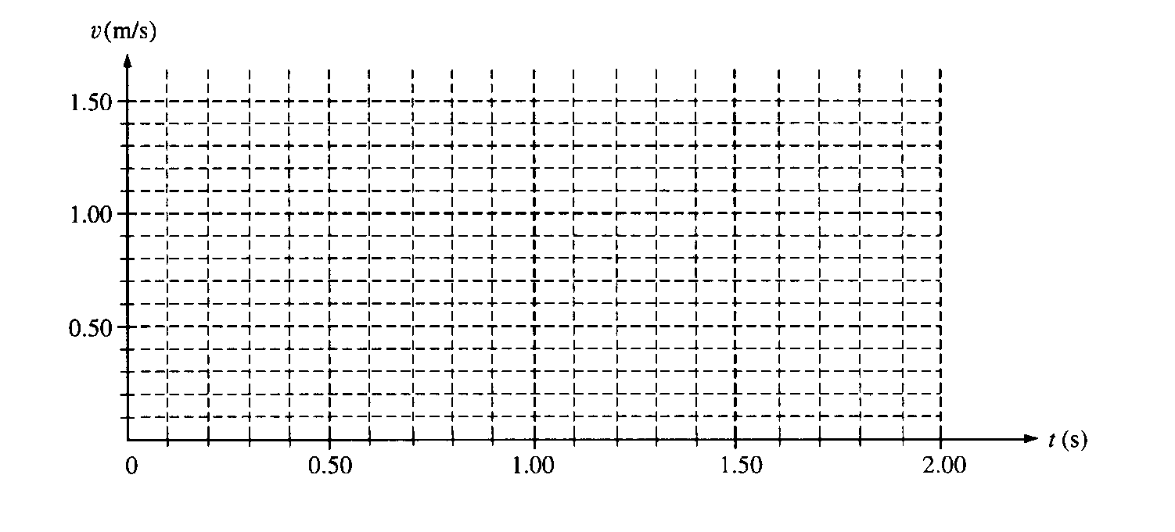

d. i. Is the collision elastic? Justify your answer without mentioning kinetic energy.

A graph of the total kinetic energy K for the two‑glider system over the 2.00 s interval has the following shape. Ko is the total kinetic energy of the system at time t = 0.

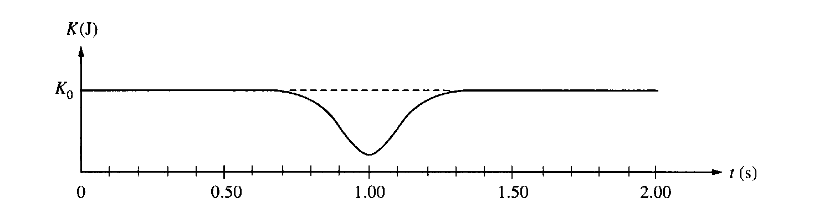

e. Briefly explain why there is a minimum in the kinetic energy curve at t = 1.00 s.

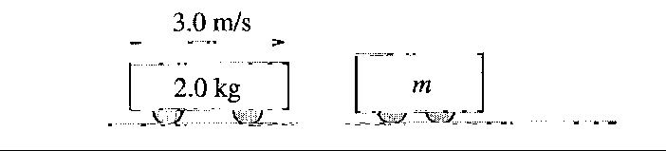

2. A 2.0 kg frictionless cart is moving at a constant speed of 3.0 m/s to the right on a horizontal surface, as shown above, when it collides with a second cart of undetermined mass *m* that is initially at rest. The force *F* of the collision as a function of time t is shown in the graph below, where *t* = 0 is the instant of initial contact. As a result of the collision, the second cart acquires a speed of 1.6 m/s to the right. Assume that friction is negligible before, during, and after the collision.

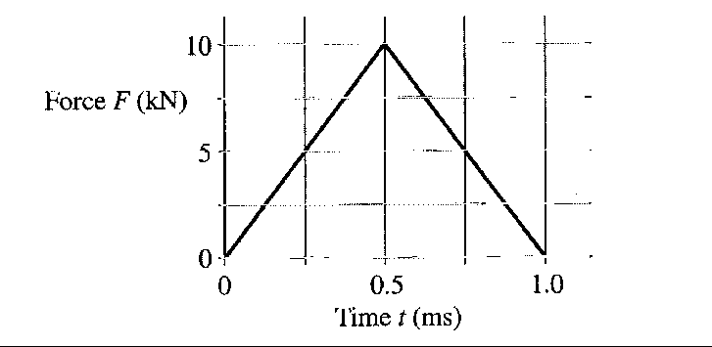

(a) Calculate the magnitude and direction of the velocity of the 2.0 kg cart after the collision.

(b) Calculate the mass *m* of the second cart.

After the collision, the second cart eventually experiences a ramp, which it traverses with no frictional losses. The graph below shows the speed *v* of the second cart as a function of time *t* for the next 5.0 s, where *t* = 0 is now the instant at which the carts separate.

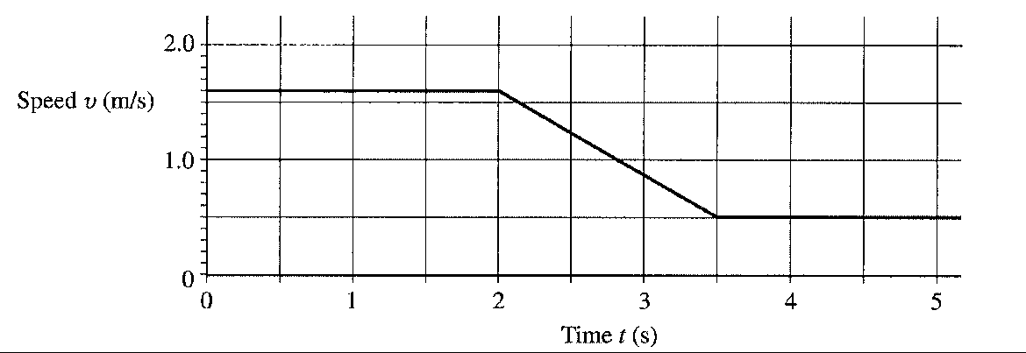

(c) Calculate the acceleration of the cart at *t* = 3.0 s.

(d) Calculate the distance traveled by the second cart during the 5.0 s interval after the collision (0 s < *t* < 5.0 s).

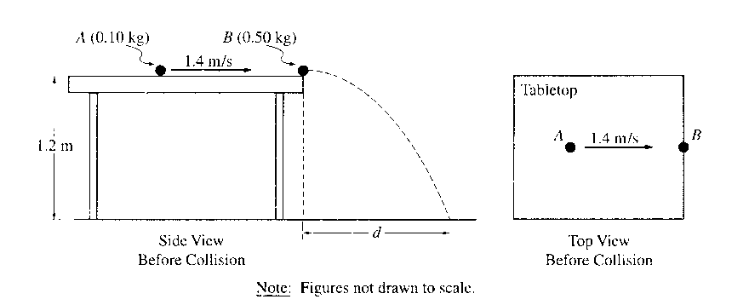

3. An incident ball A of mass 0.10 kg is sliding at 1.4 m/s on the horizontal tabletop of negligible friction shown above. It makes a head‑on collision with a target ball B of mass 0.50 kg at rest at the edge of the table. As a result of the collision, the incident ball rebounds, sliding backwards at 0.70 m/s immediately after the collision.

a. Calculate the speed of the 0.50 kg target ball immediately after the collision.

The tabletop is 1.20 m above a level, horizontal floor. The target ball is projected horizontally and initially strikes the floor at a horizontal displacement *d* from the point of collision.

b. Calculate the horizontal displacement *d.*

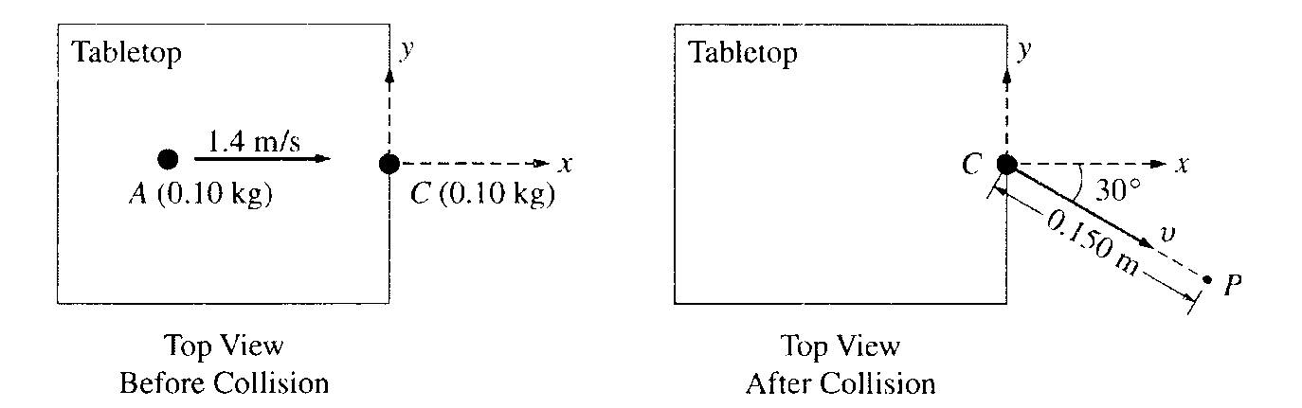

In another experiment on the same table, the target ball B is replaced by target ball C of mass 0.10 kg. The incident ball A again slides at 1.4 m/s, as shown above left, but this time makes a glancing collision with the target ball C that is at rest at the edge of the table. The target ball C strikes the floor at point P, which is at a horizontal displacement of 0.15 m from the point of the collision, and at a horizontal angle of 30° from the +x‑axis, as shown above right.

c. Calculate the speed v of the target ball C immediately after the collision.

d. Calculate the y‑component of incident ball A's momentum immediately after the collision.



4. Two identical objects A and B of mass M move on a one-dimensional, horizontal air track. Object B initially moves to the right with speed vo. Object A initially moves to the right with speed 3vo, so that it collides with object B. Friction is negligible. Express your answers to the following in terms of M and vo.

a. Determine the total momentum of the system of the two objects.

b. A student predicts that the collision will be totally inelastic (the objects stick together on collision). Assuming this is true, determine the following for the two objects immediately after the collision.

i. The speed

ii. The direction of motion (left or right)

When the experiment is performed, the student is surprised to observe that the objects separate after the collision and that object B subsequently moves to the right with a speed 2.5vo .

c. Determine the following for object A immediately after the collision.

i. The speed

ii. The direction of motion (left or right)

d. Determine the kinetic energy dissipated in the actual experiment.