Momentum 4

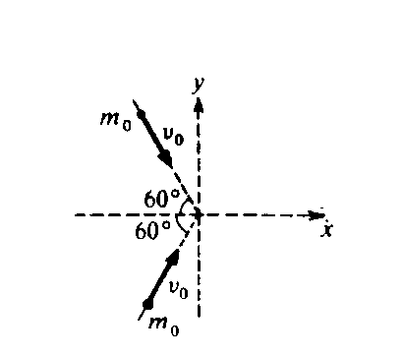

1. Two particles of equal mass mo, moving with equal speeds vO along paths inclined at 60° to the x‑axis as shown above, collide and stick together. Their velocity after the collision has magnitude

(A)  (B)  (C)  (D)  (E) *vo*

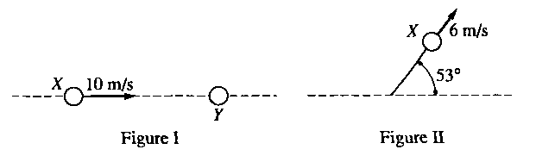

2. Two balls are on a frictionless horizontal tabletop. Ball X initially moves at 10 meters per second, as shown in Figure I above. It then collides elastically with identical ball Y. which is initially at rest. After the collision, ball X moves at 6 meters per second along a path at 530 to its original direction, as shown in Figure II above. Which of the following diagrams best represents the motion of ball Y after the collision?



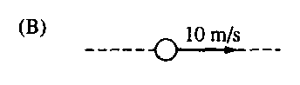

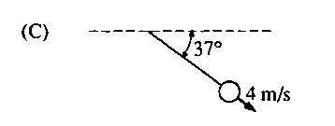

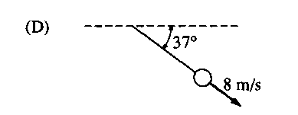

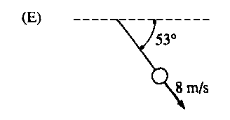

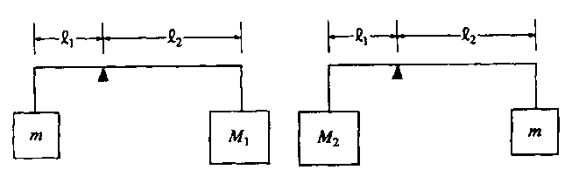

3. A rod of negligible mass is pivoted at a point that is off‑center, so that length l 1 is different from length l2. The figures above show two cases in which masses are suspended from the ends of the rod. In each case the unknown mass m is balanced by a known mass, M1 or M2, so that the rod remains horizontal. What is the value of m in terms of the known masses?

(A) Ml + M2 (B) ½(Ml + M2) (C) Ml M2 (D) ½M1M2 (E) 

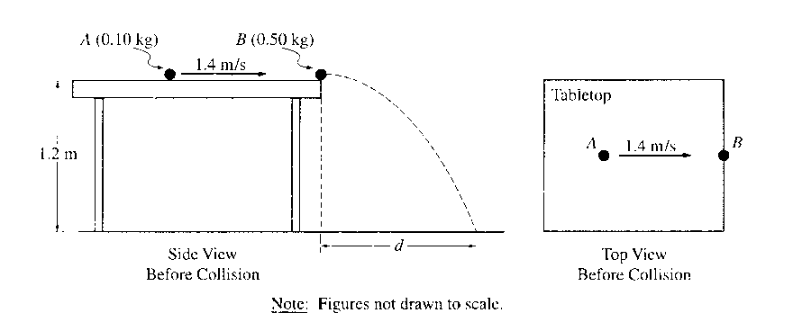

4. An incident ball A of mass 0.10 kg is sliding at 1.4 m/s on the horizontal tabletop of negligible friction shown above. It makes a head‑on collision with a target ball B of mass 0.50 kg at rest at the edge of the table. As a result of the collision, the incident ball rebounds, sliding backwards at 0.70 m/s immediately after the collision.

a. Calculate the speed of the 0.50 kg target ball immediately after the collision.

The tabletop is 1.20 m above a level, horizontal floor. The target ball is projected horizontally and initially strikes the floor at a horizontal displacement *d* from the point of collision.

b. Calculate the horizontal displacement *d.*

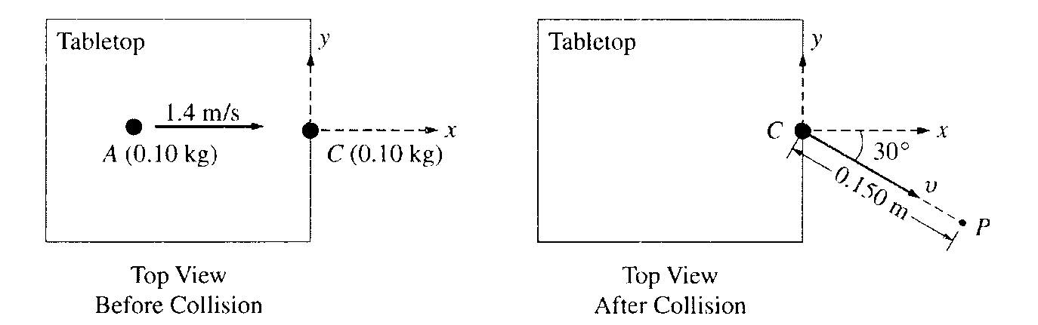

In another experiment on the same table, the target ball B is replaced by target ball C of mass 0.10 kg. The incident ball A again slides at 1.4 m/s, as shown above left, but this time makes a glancing collision with the target ball C that is at rest at the edge of the table. The target ball C strikes the floor at point P, which is at a horizontal displacement of 0.15 m from the point of the collision, and at a horizontal angle of 30° from the +x‑axis, as shown above right.

c. Calculate the speed v of the target ball C immediately after the collision.

d. Calculate the y‑component of incident ball A's momentum immediately after the collision.

5. A projectile is launched from the top of a cliff above level ground. At launch the projectile is 35 meters above the base of the cliff and has a velocity of 50 meters per second at an angle 37° with the horizontal. Air resistance is negligible. Consider the following two cases and use g = 10 m/s2 sin 37° = 0.60, and cos 37° = 0.80.

Case I: The projectile follows the path shown by the curved line in the following diagram.

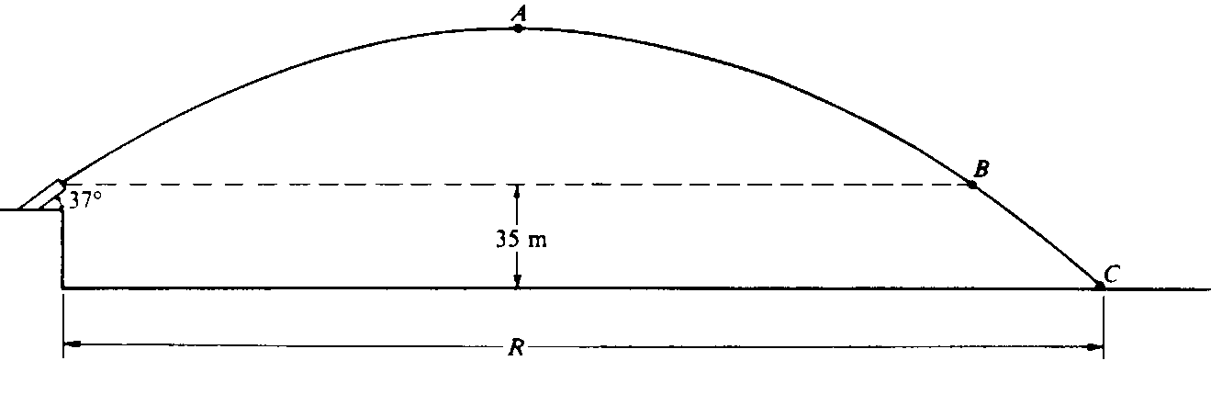

1. Calculate the total time from launch until the projectile hits the ground at point C.
2. Calculate the horizontal distance R that the projectile travels before it hits the ground.
3. Calculate the speed of the projectile at points A, B and C.

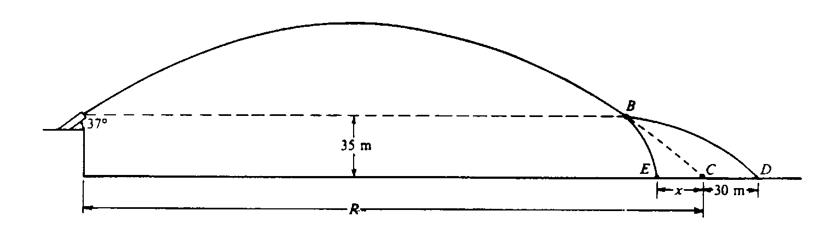

Case II: A small internal charge explodes at point B in the above diagram, causing the projectile to separate into two parts of masses 6 kilograms and 10 kilograms. The explosive force on each part is horizontal and in the plane of the trajectory. The 6‑kilogram mass strikes the ground at point D, located 30 meters beyond point C, where the projectile would have landed had it not exploded The 10‑kilogram mass strikes the ground at point E.

d. Calculate the distance x from C to *E.*