Rotation 2

- Fill in the following table.

Rotational Quantity | Name | Linear Analog | Formula (linear to rotational) | Formula(other) | Units | Description
θ
ω
α
I
τ

- Describe two things that affect the rotational inertia of an object. How do they affect the rotational inertia of an object?

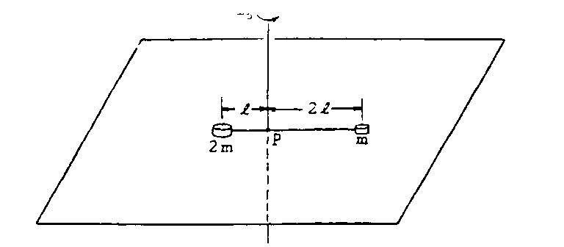
- Two masses are connected by a rod of negligible mass.
  - Find the inertia of each mass.

  - Find the rotational inertia of each mass about the pivot point.

  - Does the mass with the greatest inertia have the greatest rotational inertia? Explain why/why not.

  - Find the total inertia of the system.

  - Find the total rotational inertia of the system of two masses.
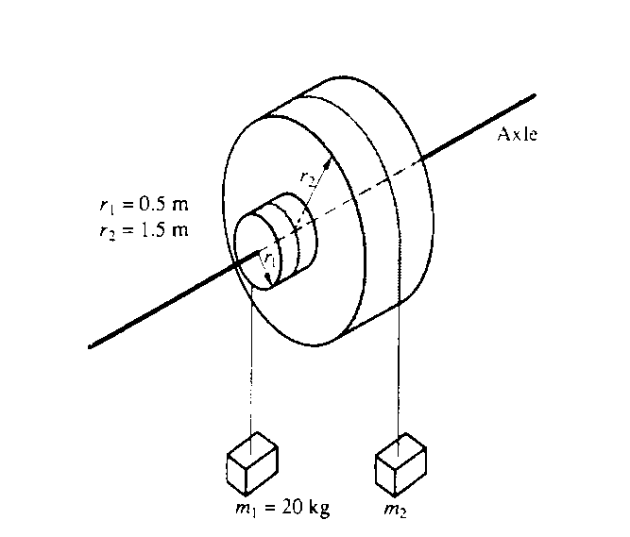
- Two masses. m₁ and m₂ are connected by light cables to the perimeters of two cylinders of radii r₁ and r₂, respectively. as shown in the diagram above. The cylinders are rigidly connected to each other but are free to rotate without friction on a common axle.
  - If the mass of the small front cylinder is 10 kg, what is its moment of inertia?

  - If the mass of the large back cylinder is 40 kg, what it its moment of inertia?

  - What is the total moment of inertia of the cylinder?

  - If m₁ is 20 kg, find mass 2 such that the cylinder remains in equilibrium.

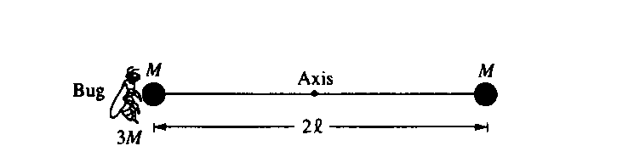
- A bug of mass 3M lands on a mass connected to another mass by a light (negligible mass) rod. The rod is free to rotate around an axis as shown.
  - Find the total rotational inertia of the system.

  - Find the torque from each mass and the bug.

  - What is the net torque on the system?

  - What is the initial angular acceleration of they system?

