Rotation 1

Tipler Ch. 9: 1, 2, 3, 5, 10, 16, 17, 18, 19, 20, 21, 22, 24

1977M2. A uniform cylinder of mass M, and radius R is initially at rest on a rough horizontal surface. The moment of inertia of a cylinder about its axis is ½MR². A string, which is wrapped around the cylinder, is pulled upwards with a force T whose magnitude is 0.6Mg and whose direction is maintained vertically upward at all times. In consequence, the cylinder both accelerates horizontally and slips. The coefficient of kinetic friction is 0.5.

a. On the diagram below, draw vectors that represent each of the forces acting on the cylinder identify and clearly label each force.

b. Determine the linear acceleration a of the center of the cylinder.

c. Calculate the angular acceleration α of the cylinder.

d. Your results should show that a and αR are not equal. Explain.
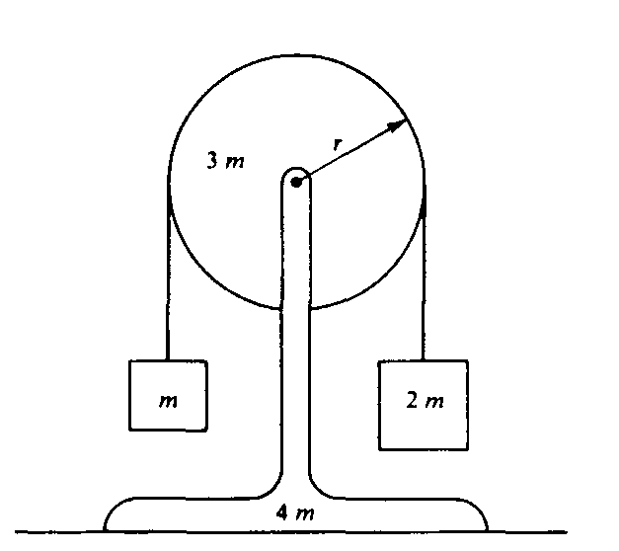
1985M3. A pulley of mass 3m and radius r is mounted on frictionless bearings and supported by a stand of mass 4m at rest on a table as shown above. The moment of inertia of this pulley about its axis is 1.5mr².
Passing over the pulley is a massless cord supporting a block of mass m on the left and a block of mass 2m on the right. The cord does not slip on the pulley, so after the block-pulley system is released from rest, the pulley begins to rotate.
a. On the diagrams below, draw and label all the forces acting on each block.
b. Use the symbols identified in part (a) to write each of the following.
i. The equations of translational motion (Newton's second law) for each of the two blocks

ii. The analogous equation for the rotational motion of the pulley

c. Solve the equations in part (b) for the acceleration of the two blocks.

d. Determine the tension in the segment of the cord attached to the block of mass m.

e. Determine the normal force exerted on the apparatus by the table while the blocks are in motion.
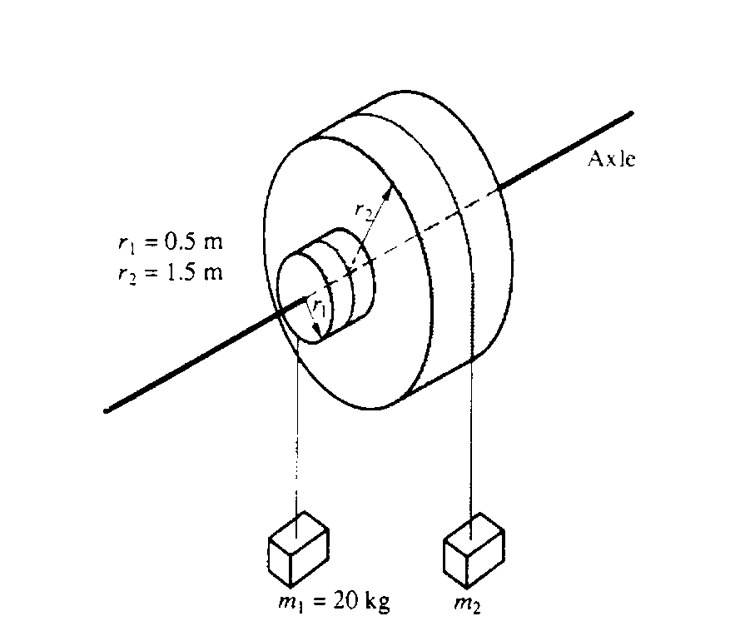
1991M2. Two masses. m₁ and m₂ are connected by light cables to the perimeters of two cylinders of radii r₁ and r₂, respectively. as shown in the diagram above. The cylinders are rigidly connected to each other but are free to rotate without friction on a common axle. The moment of inertia of the pair of cylinders is I = 45 kgm² Also r₁ = 0.5 meter, r₂ = 1.5 meters, and m₁ = 20 kilograms.
a. Determine m₂ such that the system will remain in equilibrium.

The mass m₂ is removed and the system is released from rest.
b. Determine the angular acceleration of the cylinders.

c. Determine the tension in the cable supporting m₁

d. Determine the linear speed of m ₁ at the time it has descended 1.0 meter.

