Waves 2

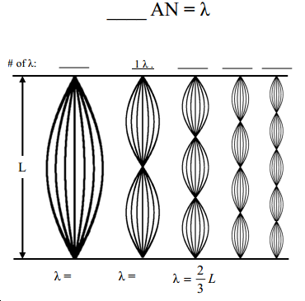
1) Fill in the equation at the right for how many antinodes (AN) equals 1 λ.

2) How many AN does the fundamental have?

3) Above the diagram, write how many wavelengths each harmonic is (H2 is already done).

4) So, how many L’s is the wavelength of the fundamental?

5) Under each harmonic, write its wavelength in terms of “L”. (H3 is already done).

6) You probably have the wavelength of the fundamental as a whole number, not a fraction. Make it a fraction, over 1.

7) Notice the denominators of harmonics 1, 3, and 5. You should see a pattern. Change the fractions of the other harmonics (2 and 4) so that the pattern is the same for all of them.

8) So, these changing denominators are the number of:

9) Calling the denominator “n” (the number of antinodes). Now write a formula for finding the wavelength of a particular harmonic on a fixed string of length “L”.

10) * On a 2.5 m string, what is the wavelength of the 8th harmonic?

11) If a mechanical vibrator is vibrating 460 times per second to produce the 8th harmonic you just found, find the speed of the wave in the string.

12) If you tighten a string, will the wavelength of the harmonics change (is the string longer)?

13) When I tighten a string what does change?

14) When the string vibrates, it beats against the air, making the air molecules vibrate, too. Every time the string pushes, the air moves, too. So, what is the same in air as in a string: the wavelength of the vibration or the frequency of the vibration?
15) What frequency sound will we hear from the string in Question 11?

16) The speed of sound in air varies between 330 m/s and 444 m/s. Let’s use V_{sound} = 340 m/s. What would be the wavelength of that sound in air?

17) A string is 1.5 m long and produces a note that has a frequency of 150 Hz when plucked. This is H1, the fundamental.
A. As a string the λ_{fundamental} = __ L.

B. So, λ_{fundamental} =

C. Calculate the speed of the wave on the string.

D. Give the first 3 possible harmonics on this string.

E. What part of the sound will be the same in air?

F. If the speed of sound in air is 343 m/s, what is the wavelength of the note in the air?

18) A 40 cm string, when struck, naturally produces a 206 Hz sound (its natural frequency, the fundamental).
A. λfundamental = __ L.

B. So, λfundamental = (in meters)

C. Calculate the speed of sound in the string.

D. Give the first 3 possible harmonics on this string

