Review

1. What power is needed to lift a 49-kg person a vertical distance of 5.0 m in 20.0 s?
A) 12.5 W B) 25 W C) 60 W D) 120 W E) 210 W

2. A warehouse worker uses a forklift to lift a crate of pickles on a platform to a height 2.75 m above the floor. The combined mass of the platform and the crate is 207 kg. If the power expended by the forklift is 1440 W, how long does it take to lift the crate?
A) 37.2 s B) 5.81 s C) 3.87 s D) 18.6 s E) 1.86 s

3. If you double the speed of an object, its kinetic energy is
A) the same. B) doubled. C) tripled. D) quadrupled. E) halved.

4.
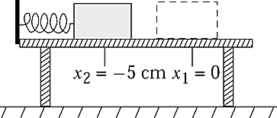
A mass m = 2.5 kg is sliding along a frictionless table with initial speed v as shown in the figure. It strikes a coiled spring that has a force constant k = 500 N/m and compresses it a distance x2 – x1 = –.050 cm. The initial speed v of the block was
A) 0.71 m/s B) 1.0 m/s C) 1.4 m/s D) 0.50 m/s E) 1.7 m/s

5.
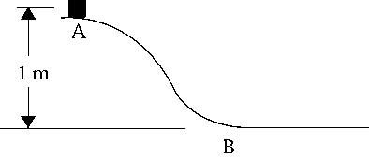
A 6.0-kg block slides from point A down a frictionless curve to point B. After the block passes point B, a friction force opposes the motion of the block so that it comes to a stop 2.5 m from B. Calculate the coefficient of kinetic friction between the block and the surface after position B.
A) 2.5 B) 0.40 C) >0.40 D) 0.40 N E) 2.5 N

6. The weight of an object on the moon is one-sixth its weight on the earth. A body moving with a given speed on the moon has kinetic energy equal to ______________ it would have if it were moving at the same speed on the earth.
A) the kinetic energy D) 6 times the kinetic energy
B) 1/36 the kinetic energy E) 36 times the kinetic energy
C) 1/6 the kinetic energy
7.
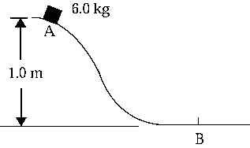
A 6.0-kg block slides from rest at position A down a frictionless incline to position B. The speed of the block at B is
A) 3.1 m/s B) 4.4 m/s C) 11 m/s D) 1.8 m/s E) 20 m/s

8. Consider two engines. The larger is rated at 2 W and the smaller at 1 W. The smaller one can do a certain quantity of work in 2 h. The larger can do twice as much work in a time of
A) 30 min B) 1 h C) 2 h D) 4 h E) 1.4 h

9. In which one of the following situations is zero net work done?
A) A ball rolls down an inclined plane.
B) A physics student stretches a spring.
C) A projectile falls toward the surface of Earth.
D) A box is pulled across a rough floor at constant velocity.
E) A child pulls a wagon across a rough surface causing it to accelerate.

10. Work may be expressed using all of the following units except:
A) N•m B) joule C) erg D) ft•lb E) watt

11. A concrete block is pulled 7.0 m across a frictionless surface by means of a rope. The tension in the rope is 40 N; and the net work done on the block is 247 J.
What angle does the rope make with the horizontal?
A) 28° B) 41° C) 47° D) 62° E) 88°

12. Brenda carries an 8.0-kg suitcase as she walks 25 m along a horizontal walkway to her room at a constant speed of 1.5 m/s. How much work does Brenda do in carrying her suitcase?
A) zero joules B) 40 J C) 200 J D) 300 J E) 2000 J

13. Which one of the following is an example of an object with a non-zero kinetic energy?
A) a drum of diesel fuel on a parked truck
B) a stationary pendulum
C) a satellite in geosynchronous orbit
D) a car parked at the top of a hill
E) a boulder resting at the bottom of a cliff

14. In which one of the following situations will there be an increase in kinetic energy?
A) A projectile approaches its maximum height.
B) A box is pulled across a rough floor at constant speed.
C) A child pushes a merry go round causing it to rotate faster.
D) A satellite travels in a circular orbit around the earth at fixed altitude.
E) A stone at the end of a string is whirled in a horizontal circle at constant speed.

15. An elevator supported by a single cable descends a shaft at a constant speed. The only forces acting on the elevator are the tension in the cable and the gravitational force. Which one of the following statements is true?
A) The magnitude of the work done by the tension force is larger than that done by the gravitational force.
B) The magnitude of the work done by the gravitational force is larger than that done by the tension force.
C) The work done by the tension force is zero joules.
D) The work done by the gravitational force is zero joules.
E) The net work done by the two forces is zero joules.

16. A woman stands on the edge of a cliff and throws a stone vertically downward with an initial speed of 10 m/s. The instant before the stone hits the ground below, it has 450 J of kinetic energy. If she were to throw the stone horizontally outward from the cliff with the same initial speed of 10 m/s, how much kinetic energy would it have just before it hits the ground?
A) 50 J B) 100 J C) 450 J D) 800 J E) 950 J

17. A rock is thrown straight up from the surface of the Earth. Which one of the following statements describes the energy transformation of the rock as it rises? Neglect air resistance.
A) The total energy of the rock increases.
B) The kinetic energy increases and the potential energy decreases.
C) Both the potential energy and the total energy of the rock increase.
D) The kinetic energy decreases and the potential energy increases.
E) Both the kinetic energy and the potential energy of the rock remain the same.

18. Complete the following statement: A force that acts on an object is said to be conservative if
A) it obeys Newton's laws of motion.
B) it results in a change in the object's kinetic energy.
C) it always acts in the direction of motion of the object.
D) the work it does on the object is independent of the path of the motion.
E) the work it does on the object is equal to the increase in the object's kinetic energy.

19. A pebble rolls off the roof of Science Hall and falls vertically. Just before it reaches the ground, the pebble's speed is 17 m/s. Neglect air resistance and determine the height of Science Hall.
A) 42 m B) 33 m C) 26 m D) 21 m E) 15 m

20. A roller-coaster car is moving at 20 m/s along a straight horizontal track. What will its speed be after climbing the 15-m hill shown in the figure if friction is ignored?
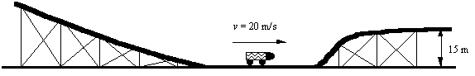
A) 17 m/s B) 7 m/s C) 5 m/s D) 10 m/s E) 14 m/s

21. A skier leaves the top of a slope with an initial speed of 5.0 m/s. Her speed at the bottom of the slope is 13 m/s. What is the height of the slope?
A) 1.1 m B) 4.6 m C) 6.4 m D) 7.3 m E) 11 m

